**Task 1.**

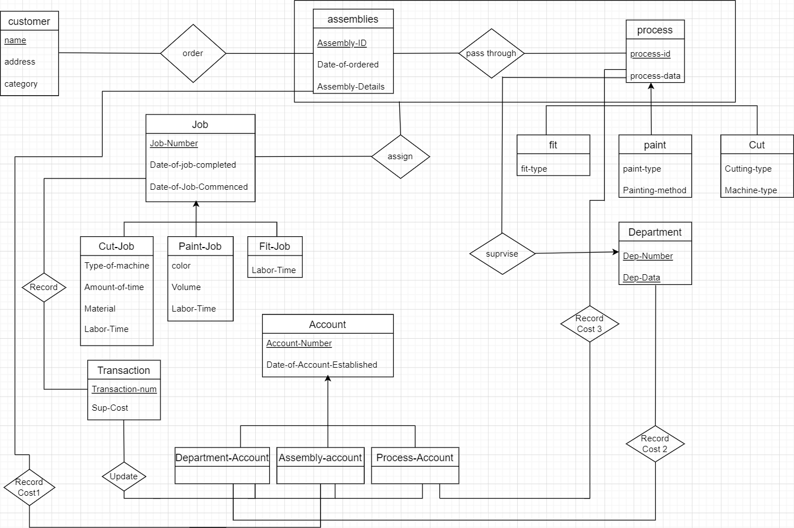

**Task 1.2. 1.2. Relational Database Schema**

Customer (name ,address ,category)

Assembly (Assembly-id ,date-of-ordered ,Assembly-details)

Process (Process-Id ,Process-data)

Order (Assembly-id ,cname)

Fit (Process-Id ,Fit-type)

Paint (Process-Id ,paint-type ,Painting-method)

Cut (process-Id, Cutting-type ,Machine-type)

Job (Job-number ,Date-of-job-commenced ,Date-of-job-completed)

Cut-job (Job-number , type-of-machine ,amount-of-time ,material ,labor-time )

Paintjob (job-number , color, volume ,labor-time)

Fitjob (Job-number ,labor-time)

Account (Account-number ,date-of-account-established)

Department-account (Account-number)

Assembly-account (Account-number)

Process-account (account-number)

Transaction (Transaction-num, sup-cost)

Department (Dep-num, Dep-data)

Assign(Assembly-id, process-Id, job-number)

Pass-through(Assembly-id, process-Id)

Record(transaction-num, job-number)

Record cost 3(Account-number, process-Id)

Record cost 2 (Account-number, dep-number)

Record cost 1 (Account-number, Assembly-id)

Supervise (process-Id, Dep-number, Dep-data)

Update (transaction-num, Account-Number)

Task 2. Data Dictionary

<Customer>

|  |  |  |  |
| --- | --- | --- | --- |
| Field Name | Data Type | Size | Constraints |
| Name | Varchar | 32 Byte | Primary Key |
| Address | Varchar | 32 Byte |  |
| Category | Integer | 4 Byte | 1-10 |

<Assembly>

|  |  |  |  |
| --- | --- | --- | --- |
| Field Name | Data Type | Size | Constraints |
| Assembly-ID | INT | 5 | Primary Key, Not Null |
| Date-Of-Ordered | Datetime | 8 |  |
| Assembly-Details | Varchar | 32 Byte |  |

<Assign>

|  |  |  |  |
| --- | --- | --- | --- |
| Field Name | Data Type | Size | Constraints |
| Assembly-ID | INT | 5 | Primary Key, Not Null |
| Process-ID | INT | 5 | Primary Key, Not Null |
| Job nom | INT | 5 | Primary Key, Not Null |

<Pass-through>

|  |  |  |  |
| --- | --- | --- | --- |
| Field Name | Data Type | Size | Constraints |
| Assembly-ID | INT | 5 | Primary Key, not null |
| Process-ID | INT | 5 | Primary Key, not null |

<Process>

|  |  |  |  |
| --- | --- | --- | --- |
| Field Name | Data Type | Size | Constraints |
| Process-ID | INT | 5 | Primary Key, not null |
| Process-Data | Varchar | 32 |  |

<Order>

|  |  |  |  |
| --- | --- | --- | --- |
| Field Name | Data Type | Size | Constraints |
| Assembly-ID | INT | 5 | Primary Key, not null |
| CName | Varchar | 32 | Primary Key, not null |

<Fit>

|  |  |  |  |
| --- | --- | --- | --- |
| Field Name | Data Type | Size | Constraints |
| Process-ID | INT | 5 | Primary Key |
| Fit-Type | Varchar | 32 |  |

<Paint>

|  |  |  |  |
| --- | --- | --- | --- |
| Field Name | Data Type | Size | Constraints |
| Process-ID | INT | 5 | Primary Key, Not null |
| Paint Type | Varchar | 32 |  |
| Painting-Method | Varchar | 32 |  |

<Cut>

|  |  |  |  |
| --- | --- | --- | --- |
| Field Name | Data Type | Size | Constraints |
| Process- ID | INT | 32 | Primary Key, Not null |
| Machine-Type | Varchar | 32 |  |
| Cutting-Type | Varchar | 32 |  |

<Job>

|  |  |  |  |
| --- | --- | --- | --- |
| Field Name | Data Type | Size | Constraints |
| Job-Nom | INT | 5 | Primary Key, Not null |
| Date-Of-Job-Commenced | datetime | 8 |  |
| Date-Of-Job-Completed | datetime | 8 |  |

<Cut-Job>

|  |  |  |  |
| --- | --- | --- | --- |
| Field Name | Data Type | Size | Constraints |
| Type-Of-Machine | Varchar | 32 |  |
| Amount-Of-Time | INT | 5 |  |
| Material | Varchar | 32 |  |
| Labor-Time | INT | 5 |  |
| Job-Nom | INT | 5 | Primary Key, Not null |

<Paint-Job>

|  |  |  |  |
| --- | --- | --- | --- |
| Field Name | Data Type | Size | Constraints |
| Job-Nom | INT | 5 | Primary Key, Not null |
| Color | Varchar | 32 |  |
| Volume | Varchar | 32 |  |
| Labor-Time | INT | 5 |  |

<Fit-Job>

|  |  |  |  |
| --- | --- | --- | --- |
| Field Name | Data Type | Size | Constraints |
| Job-Nom | INT | 5 | Primary Key, Not null |
| Labor-Time | INT | 5 |  |

<Account>

|  |  |  |  |
| --- | --- | --- | --- |
| Field Name | Data Type | Size | Constraints |
| Account-Number | INT | 5 | Primary Key, Not null |
| Date-Of-Account-Established | Datetime | 8 |  |

Department

|  |  |  |  |
| --- | --- | --- | --- |
| Field Name | Data Type | Size | Constraints |
| Department-Num | INT | 5 | Primary Key, Not null |
| Department-Data | Varchar | 32 | Primary Key, Not null |

<Department-Account>

|  |  |  |  |
| --- | --- | --- | --- |
| Field Name | Data Type | Size | Constraints |
| Account-Number | INT | 5 | Primary Key, Not null |

<Assembly-Account>

|  |  |  |  |
| --- | --- | --- | --- |
| Field Name | Data Type | Size | Constraints |
| Account-Number | INT | 5 | Primary Key, Not null |

<Process-Account>

|  |  |  |  |
| --- | --- | --- | --- |
| Field Name | Data Type | Size | Constraints |
| Account-Number | INT | 5 | Primary Key, Not null |

<Transaction>

|  |  |  |  |
| --- | --- | --- | --- |
| Field Name | Data Type | Size | Constraints |
| Transaction-Number | INT | 5 | Primary Key, Not null |
| Sup Cost | INT | 5 |  |
|  |  |  |  |

<Record>

|  |  |  |  |
| --- | --- | --- | --- |
| Field Name | Data Type | Size | Constraints |
| Transaction-Number | INT | 5 | Primary Key, Not null |
| Sup Cost | INT | 5 |  |

Record cost2

|  |  |  |  |
| --- | --- | --- | --- |
| Field Name | Data Type | Size | Constraints |
| Account-Number | INT | 5 | Primary Key, Not null |
| Department number | INT | 5 | Primary Key, Not null |

Record Cost1

|  |  |  |  |
| --- | --- | --- | --- |
| Field Name | Data Type | Size | Constraints |
| Account-Number | INT | 5 | Primary Key, Not null |
| Assembly-id | INT | 5 | Primary Key, Not null |

Record Cost3

|  |  |  |  |
| --- | --- | --- | --- |
| Field Name | Data Type | Size | Constraints |
| Account-Number | INT | 5 | Primary Key, Not null |
| Process-id | INT | 5 | Primary Key, Not null |

Supervise

|  |  |  |  |
| --- | --- | --- | --- |
| Field Name | Data Type | Size | Constraints |
| Process-ID | INT | 5 | Primary Key, Not null |
| Department number | INT | 5 | Primary Key, Not null |
| Department Data | Varchar | 32 | Primary Key, Not null |

Update

|  |  |  |  |
| --- | --- | --- | --- |
| Field Name | Data Type | Size | Constraints |
| Transaction-number | INT | 5 | Primary Key, Not null |
| Account number | INT | 5 | Primary Key, Not null |

**Task 3.**

3.1. Discussion of storage structures for tables

|  |  |  |  |  |  |
| --- | --- | --- | --- | --- | --- |
| Table Name | Query# and Type | Search Key | Query Frequency | Selected File Organization | Justifications |
| customer | (1).insert  13. range search | category | 30/day  100/day | Index sequential  On search key  category | Because it is  Range search  We use index  sequential |
| Assembly | 4.insert |  | 40/day | Heap file | Because it is  insert |
| Record cost 3 | 5. insert |  | 10/day | Heap file | Because it is  insert |
| Assign | 6. insert |  | 50/day | Heap file | Because it is  insert |
| Record cost 1 | 5.insert |  | 10/day | Heap file | Because it is  insert |
| Process | 3.insert |  | infrequent | Heap file | Because it is  insert |
| Department | 3.insert |  | infrequent | Heap file | Because it is  insert |
| Order | 4.insert |  | 40/day | Heap file | Because it is  insert |
| Pass through | 4.enter  11. Retrieve | Process-id | 40/day  100/day | Dynamic hashing  With hash key  Process id | Because retrieve  Is like random  search |
| Account | 5.create |  | 10/day | Heap file | Because it is  insert |
| Record cost 2 | 5.create |  | 10/day | Heap file | Because it is  insert |
| Record cost 1 | 5.create |  | 10/day | Heap file | Because it is  insert |
| Job | 6.insert  12. Retrieve  12. Random search | Given date | 50/day  20/day  20/day | Heap file | Because it is  insert |
| Cut-job | 7.enter  14.Delete  14.range search | Job -no | 50/day  1/month  1/month | Heap file | Because it is  insert |
| Pain-job | 7.enter  14. change |  | 50/day  1/month | Heap file | Because it is  insert |
| Fit-job | 7.insert |  |  | Heap file | Because it is  insert |
| Transaction | 8.insert |  |  | Heap file | Because it is  insert |
| Update |  |  |  |  |  |
| Department  account |  |  |  |  |  |
| Assembly  account |  |  |  |  |  |
| Process  account |  |  |  |  |  |
| Record cost 1 | 9.Retrieve |  | 200/day | Dynamic hashing  With hash key  Assembly id or  Account number | Because retrieve  Is like random  search |

**3.2. Discussion of storage structures for tables (Azure SQL Database)**

**Task 4.**

CREATE TABLE process()

processId int,

processData VARCHAR(32),

PRIMARY key (processId)

);

CREATE TABLE fit (

fittype varchar(32),

processId int,

primary key (processId),

foreign KEY (processId) references process(processId)

);

CREATE TABLE paint (

painttype varchar(32),

paintingmethod varchar(32),

processId INT,

primary key (processId),

foreign KEY (processId) references process(processId)

);

CREATE TABLE cut (

cuttingtype varchar(32),

machinetype varchar(32),

processId INT,

primary key (processId),

foreign KEY (processId) references process(processId)

);

create table Job(

jobNomber int,

dateofjobcommenced int,

dateofjobcompleted int,

primary key(jobNomber)

);

create table fitjob(

jobNomber int,

labortime int,

primary key(jobNomber),

foreign key (jobNomber) references Job(jobNomber)

);

create table painjob(

jobNomber int,

labortime int,

color varchar(15),

amountoftime int,

primary key(jobNomber),

foreign key (jobNomber) references Job(jobNomber)

);

create table cutjob(

jobNomber int,

labortime int,

color varchar(15),

amountoftime int,

typeofmachine varchar(32),

primary key(jobNomber),

foreign key (jobNomber) references Job(jobNomber)

);

CREATE TABLE passthrugh(

Assemblyid int,

processId int,

PRIMARY key(Assemblyid, processId),

FOREIGN KEY (Assemblyid) REFERENCES Assembly(Assemblyid),

FOREIGN KEY (processId) REFERENCES process(processId)

);

CREATE TABLE account (

accountnumber int,

dateofaccount int,

primary key (accountnumber)

);

create TABLE departmentaccount(

accountnumber INT,

sup_cost REAL,

PRIMARY KEY(accountnumber)

FOREIGN KEY(accountnumber) REFERENCES account(accountnumber)

);

create TABLE assemblyaccount(

accountnumber INT,

sup_cost REAL,

PRIMARY KEY(accountnumber),

FOREIGN KEY(accountnumber) REFERENCES account(accountnumber)

);

create TABLE processaccount(

accountnumber INT,

sup_cost REAL,

PRIMARY KEY(accountnumber),

FOREIGN KEY(accountnumber) REFERENCES account(accountnumber)

);

CREATE TABLE Transaction1(

transactionnumber ,

sup_cost REAL,

PRIMARY KEY(transactionnumber)

);

CREATE TABLE Assembly (

Assemblyid int,

address varchar(32),

dateofordered INT,

AssemblyDeatails varchar(80),

primary key(Assemblyid)

);

CREATE TABLE assign(

Assemblyid int,

processId int,

jobnomber INT

PRIMARY key(Assemblyid, processId, jobnomber),

FOREIGN KEY (Assemblyid) REFERENCES Assembly(Assemblyid),

FOREIGN KEY (processId) REFERENCES process(processId),

FOREIGN KEY (jobnomber) REFERENCES Job(jobnomber)

);

CREATE TABLE record(

transactionnumber int,

jobnomber INT

PRIMARY key(transactionnumber, jobnomber)

);

CREATE TABLE order1(

Assemblyid int,

cname int,

PRIMARY key(Assemblyid, cname),

FOREIGN KEY (cname) REFERENCES customer(cname),

FOREIGN KEY (Assemblyid) REFERENCES Assembly(Assemblyid)

);

CREATE TABLE department(

departmentnumber int,

departmentdata VARCHAR(70),

PRIMARY KEY(departmentnumber,departmentdata),

);

CREATE TABLE supervise(

processId int,

departmentnumber int,

departmentdata VARCHAR(32),

PRIMARY key(processId, departmentnumber, departmentdata),

FOREIGN KEY (processId) REFERENCES process(processId),

FOREIGN KEY (departmentnumber) REFERENCES department(departmentnumber),

);

create table record_dept_cost(

account_num INT,

dept_num INT,

PRIMARY KEY(account_num, dept_num),

FOREIGN KEY(account_num) REFERENCES departmentaccount(accountnumber),

FOREIGN KEY(dept_num) REFERENCES department(departmentnumber),

);

create table record_assembly_cost(

account_num INT,

assembly_id INT,

PRIMARY KEY(account_num, assembly_id),

FOREIGN KEY(account_num) REFERENCES assemblyaccount(accountnumber),

FOREIGN KEY(assembly_id) REFERENCES assembly(Assemblyid),

);

create table record_process_cost(

account_num INT,

process_id INT,

PRIMARY KEY(account_num, process_id),

FOREIGN KEY(account_num) REFERENCES processaccount(accountnumber),

FOREIGN KEY(process_id) REFERENCES process(processId),

);

create table record_cost(

account_num INT,

process_id INT,

PRIMARY KEY(account_num, process_id),

FOREIGN KEY(account_num) REFERENCES account(accountnumber),

FOREIGN KEY(process_id) REFERENCES process(processId)

);

CREATE TABLE customer(

cname int,

caddress VARCHAR(32),

category INT,

PRIMARY KEY(cname),

CONSTRAINT CHK_category CHECK (category IN ('1','2','3','4','5','6','7','8','9','10'))

);

CREATE TABLE update1(

transactionnumber INT,

FOREIGN KEY (transactionnumber) REFERENCES transaction1(transactionnumber),

FOREIGN KEY (accountnumber) REFERENCES account(accountnumber)

);

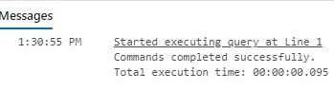

**Task 5.1**

**(Attention: I talked to the TA (Taras Basiuk) and he said that showing the implementation of the queries in the Java program is enough for this exercise. And it does not need to be implemented in azure SQL. However, I implemented most of the queries in SQL, but the full version is at the end of this section, which was implemented in Java.)**

**Query 1.**

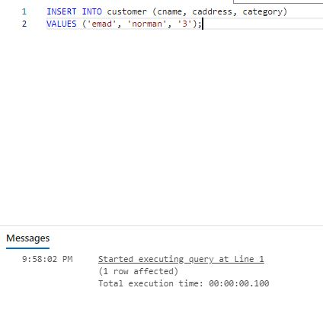

**Query 2.**

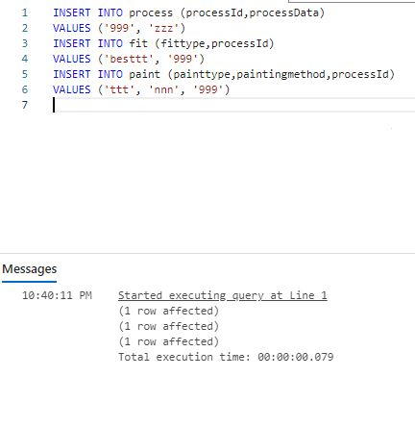

**Query 3.**

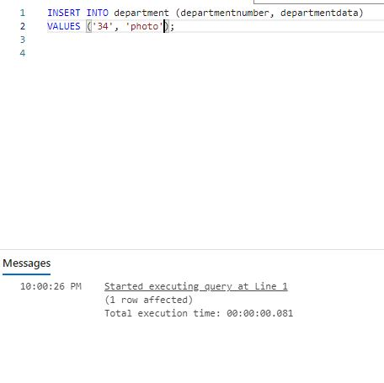

**Query 4.**

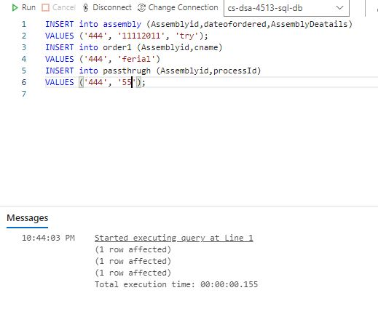

**Query 6.**

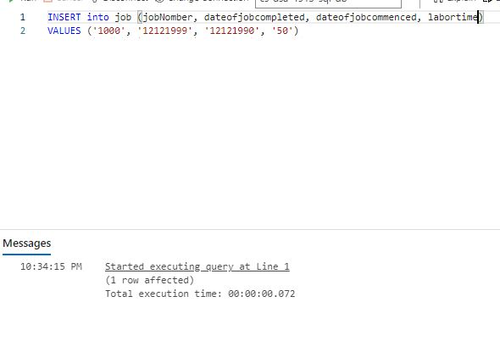

**Query 10.**

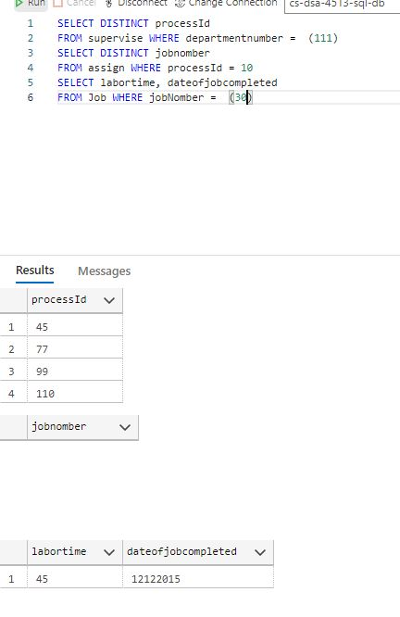

**Query 11.**

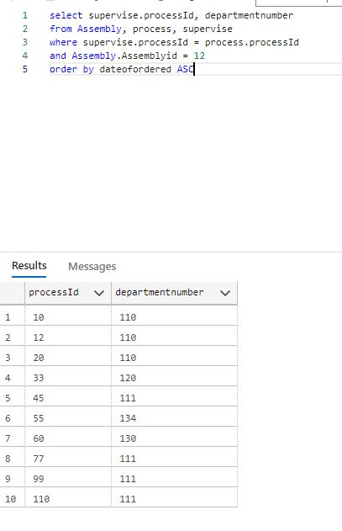

**Query 12.**

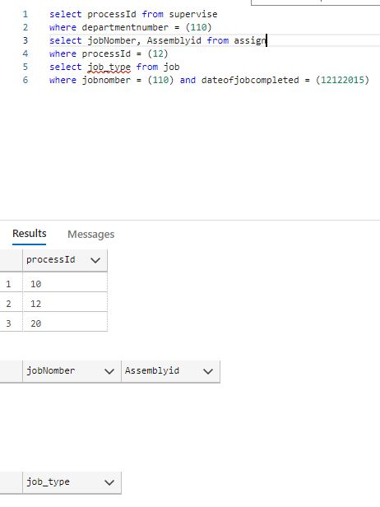

**Query 13.**

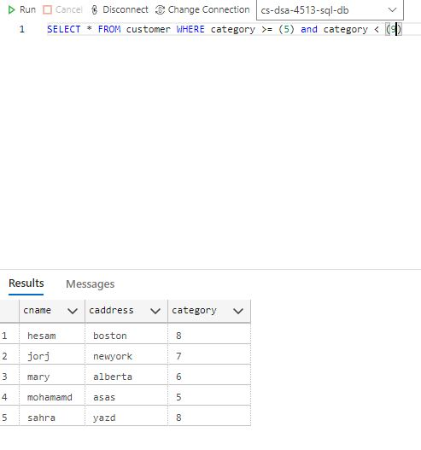

**Query 14.**

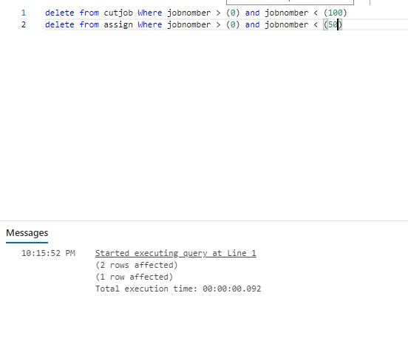

**Query 15.**

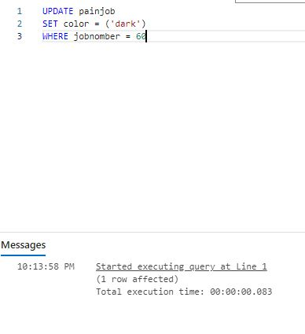

**All Queries in Java.**

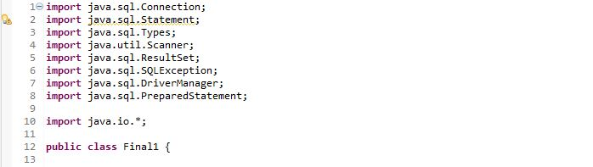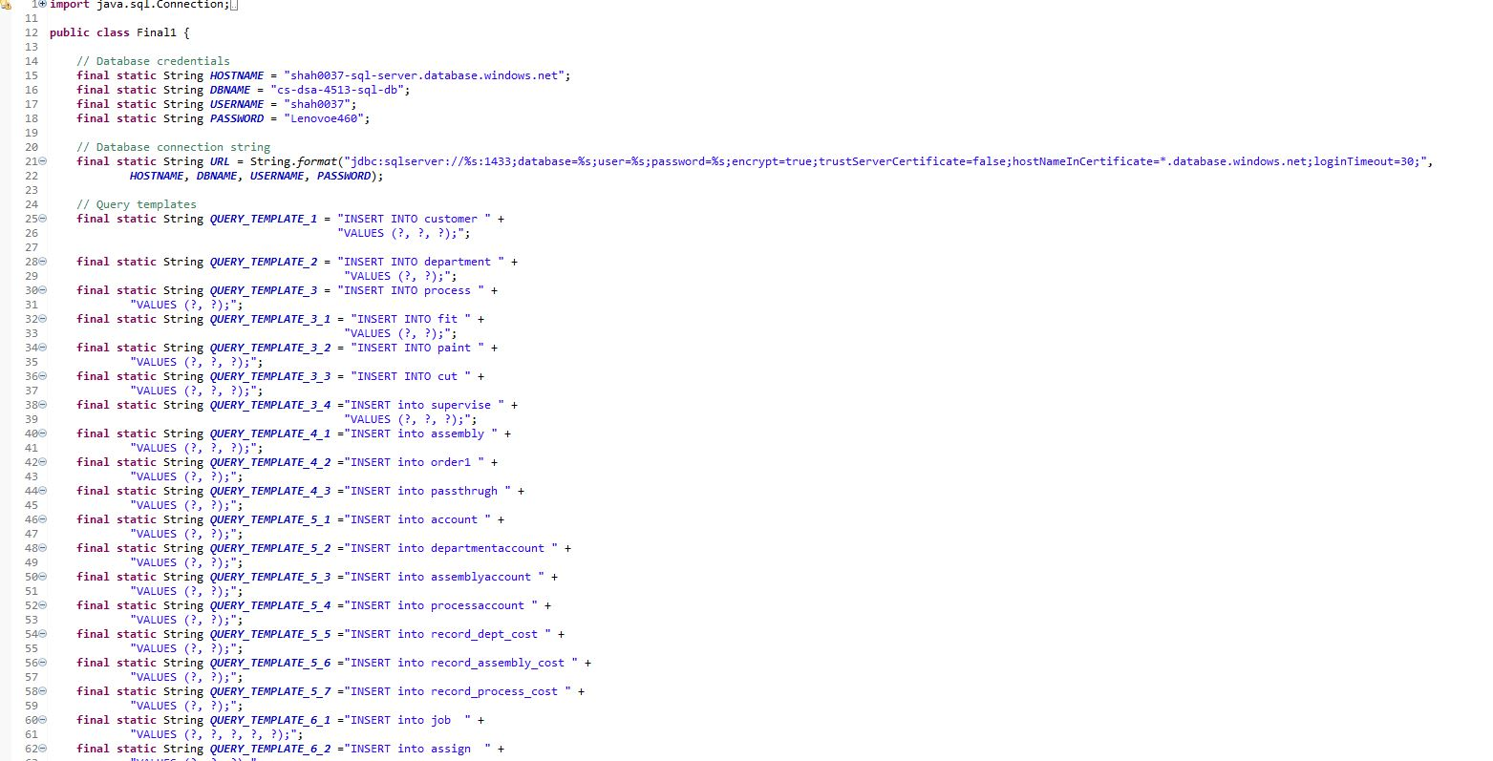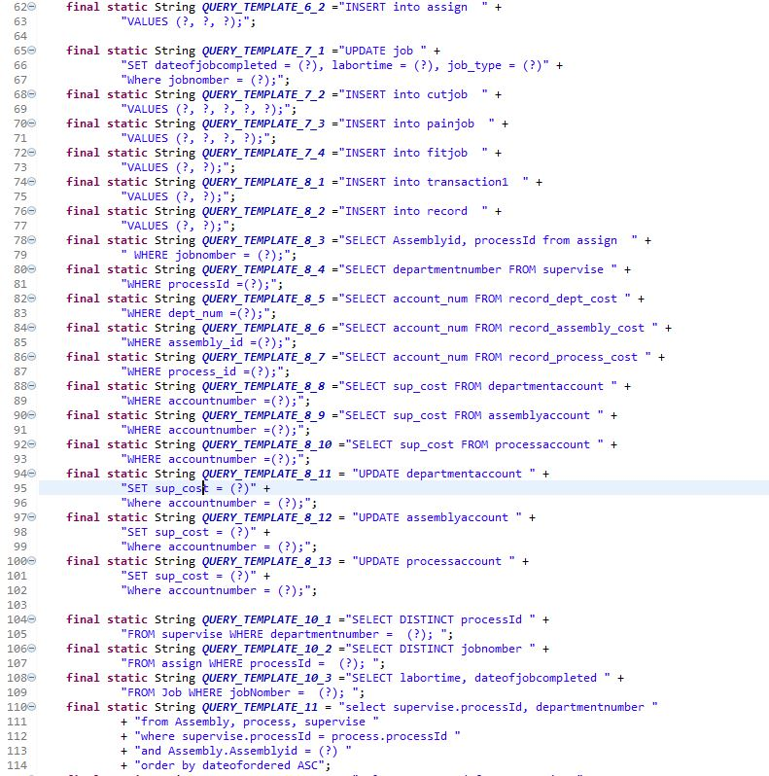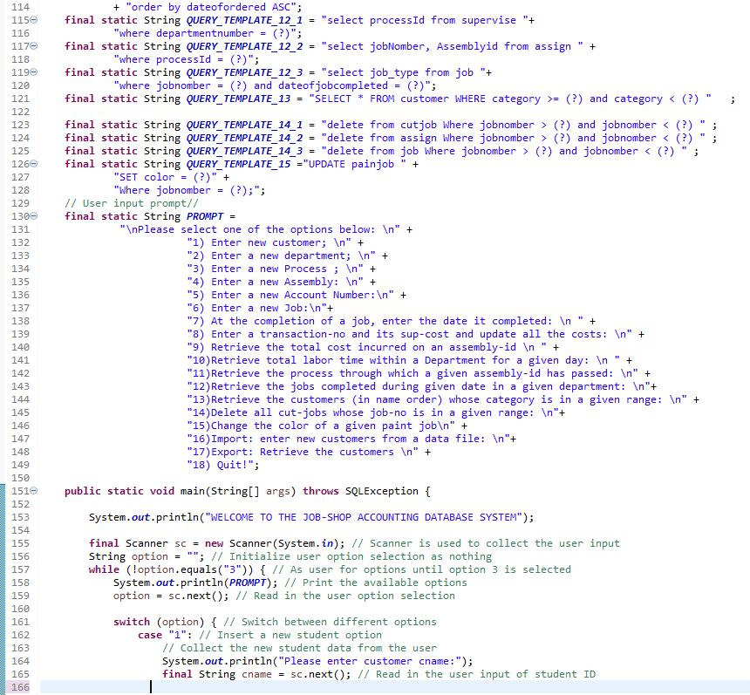

**Task 5.2:**

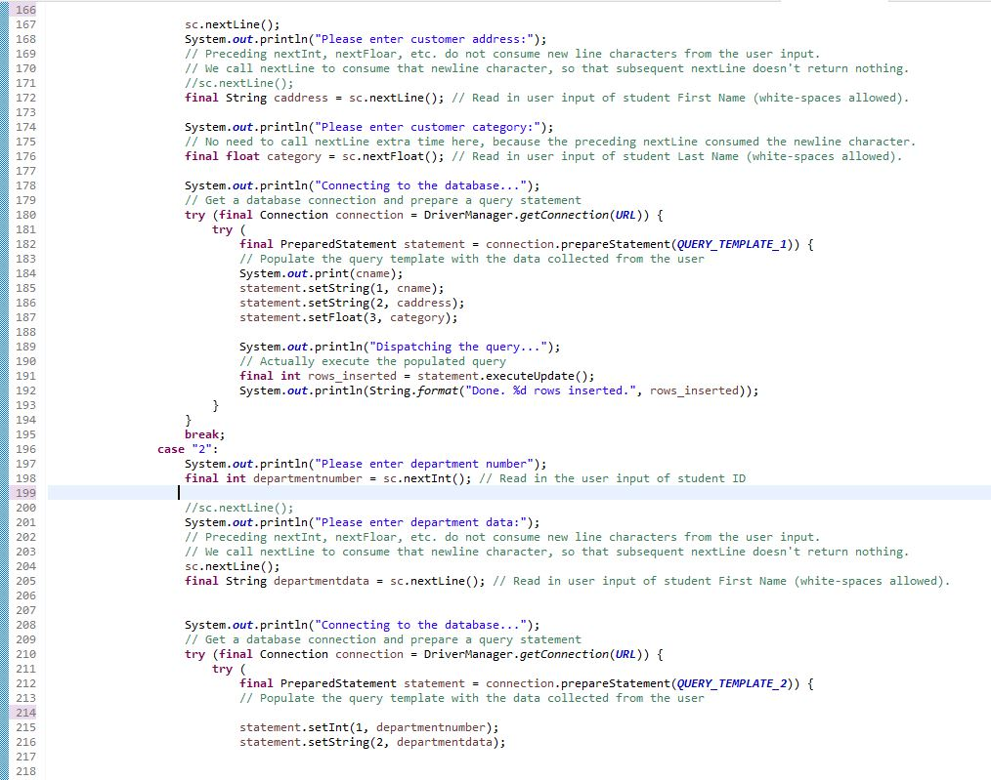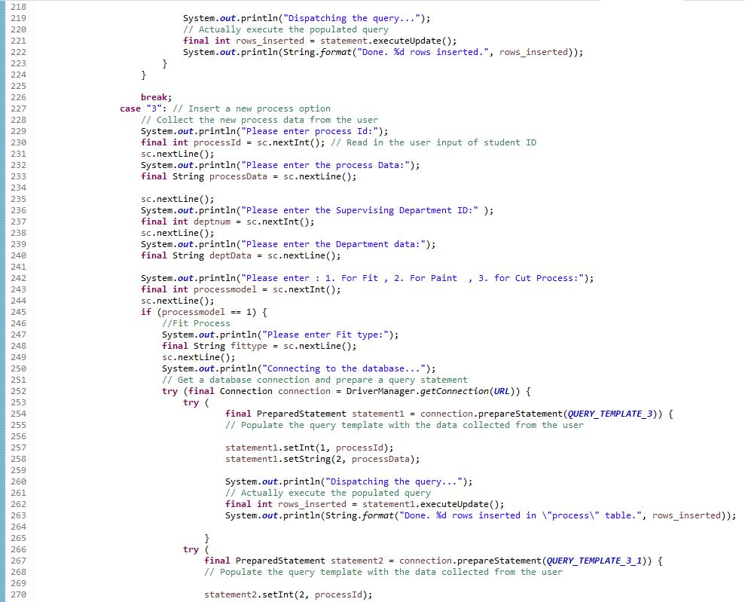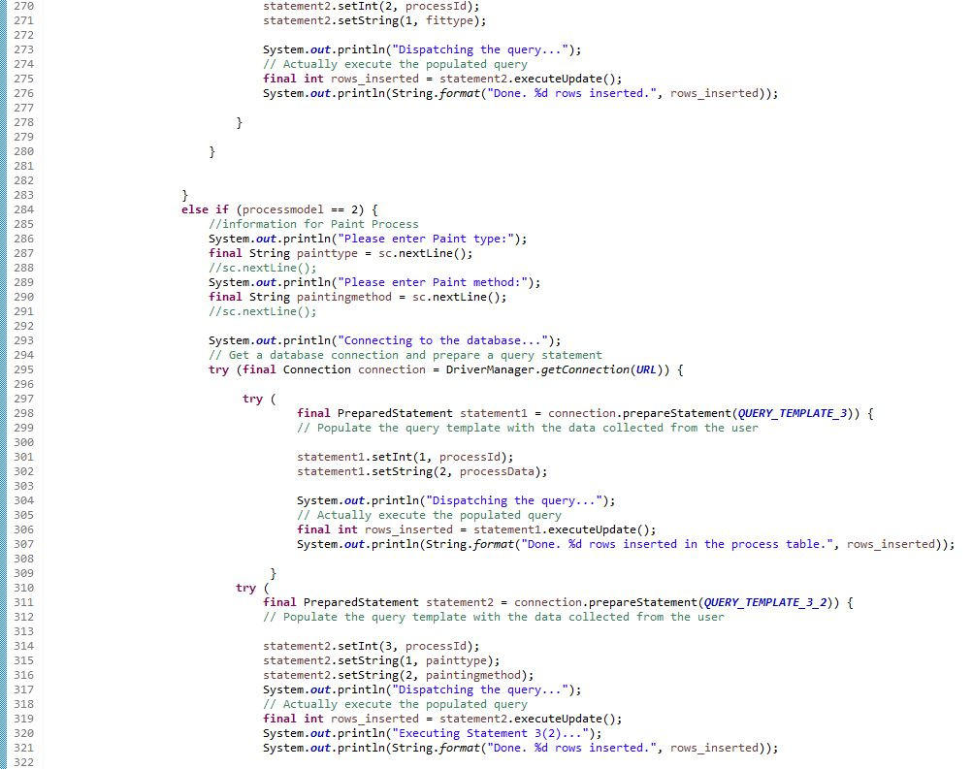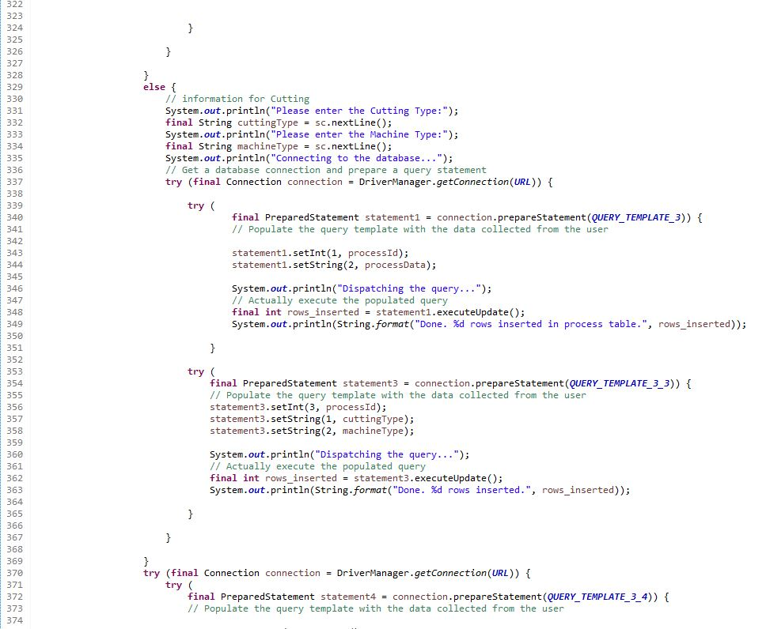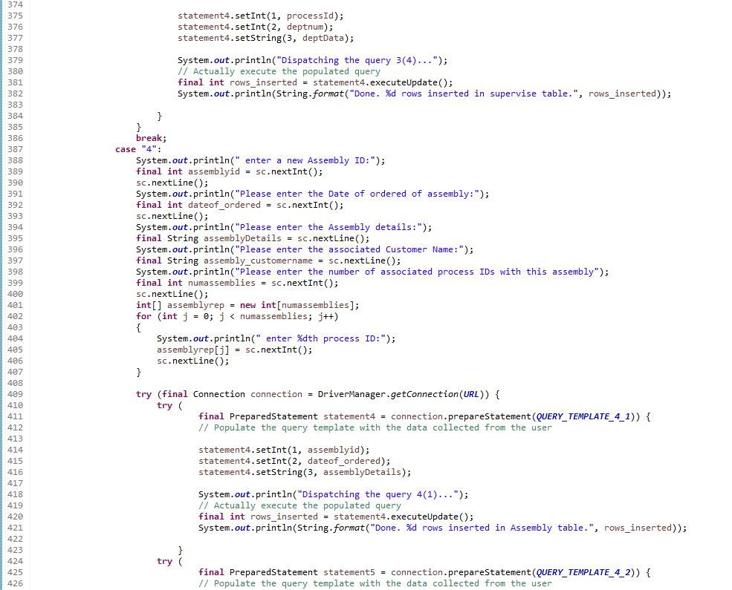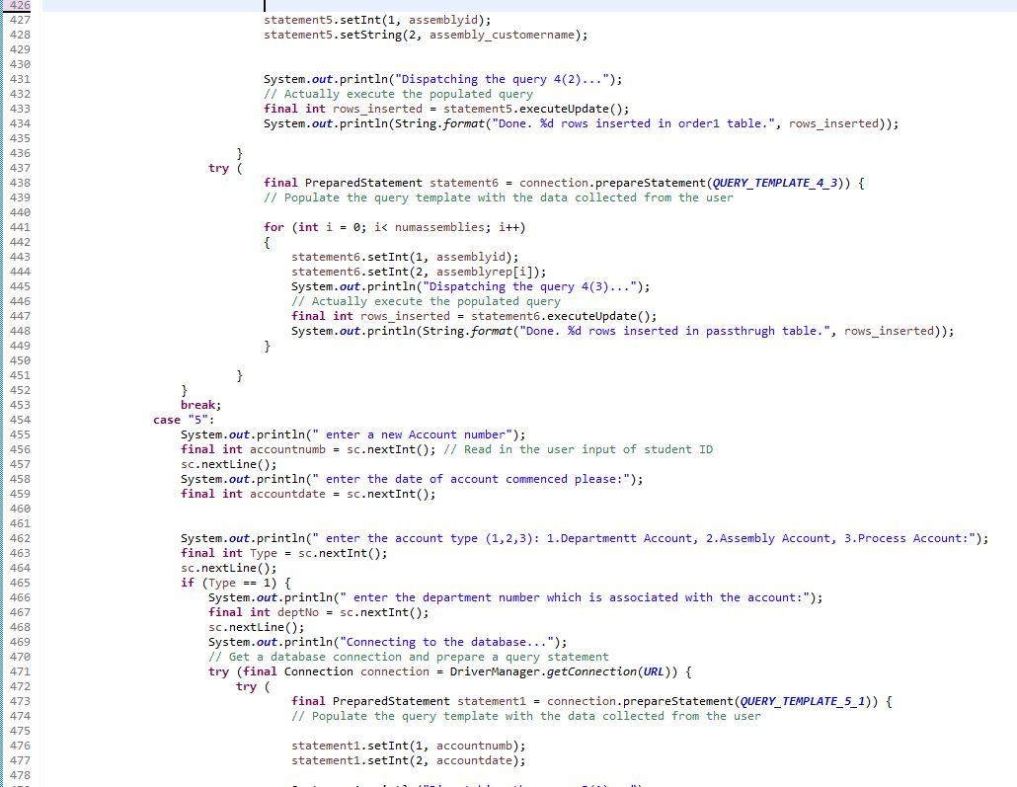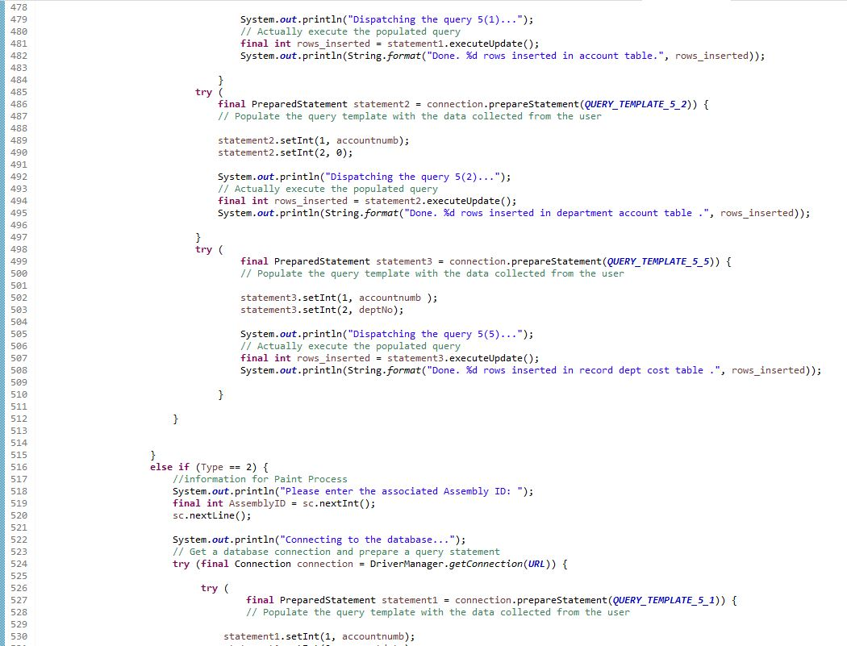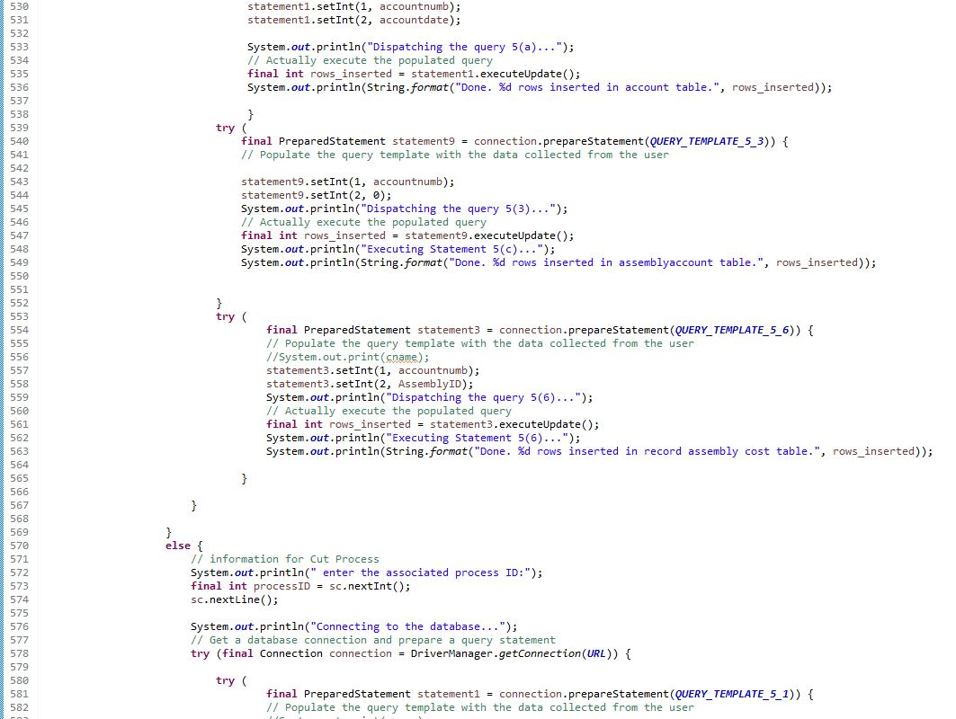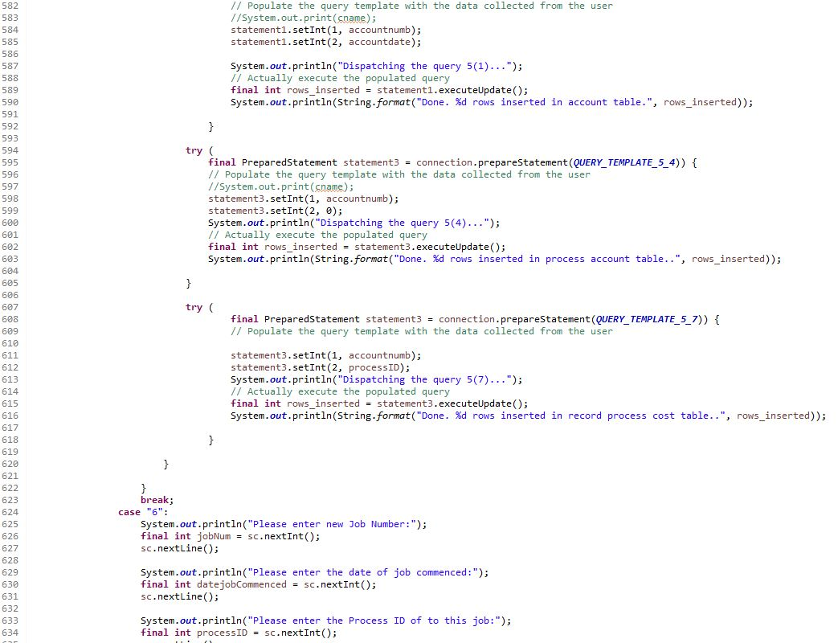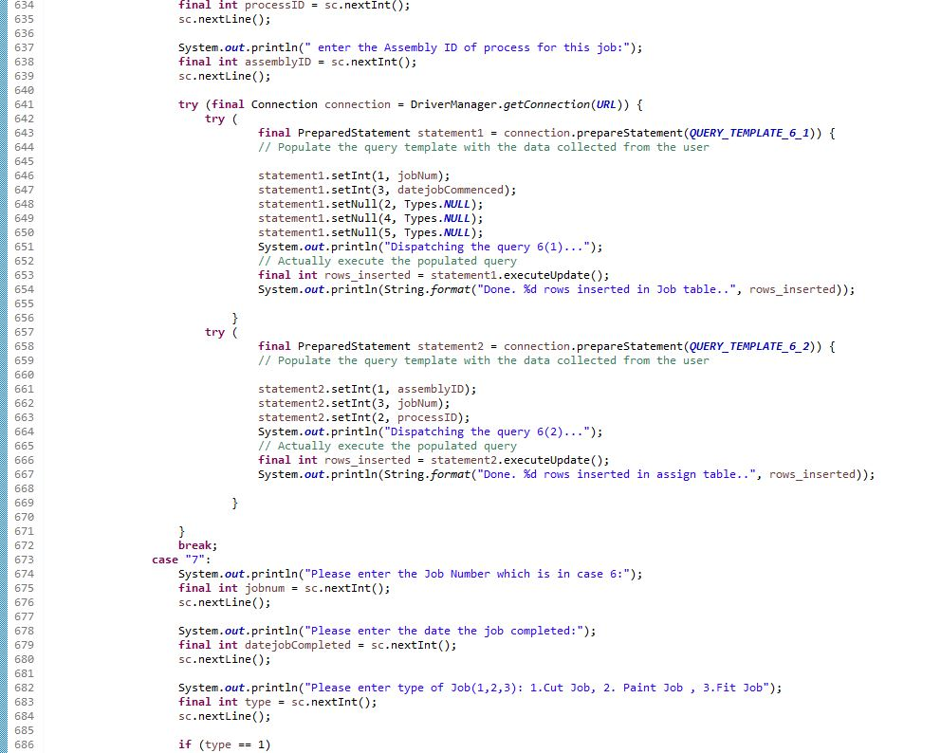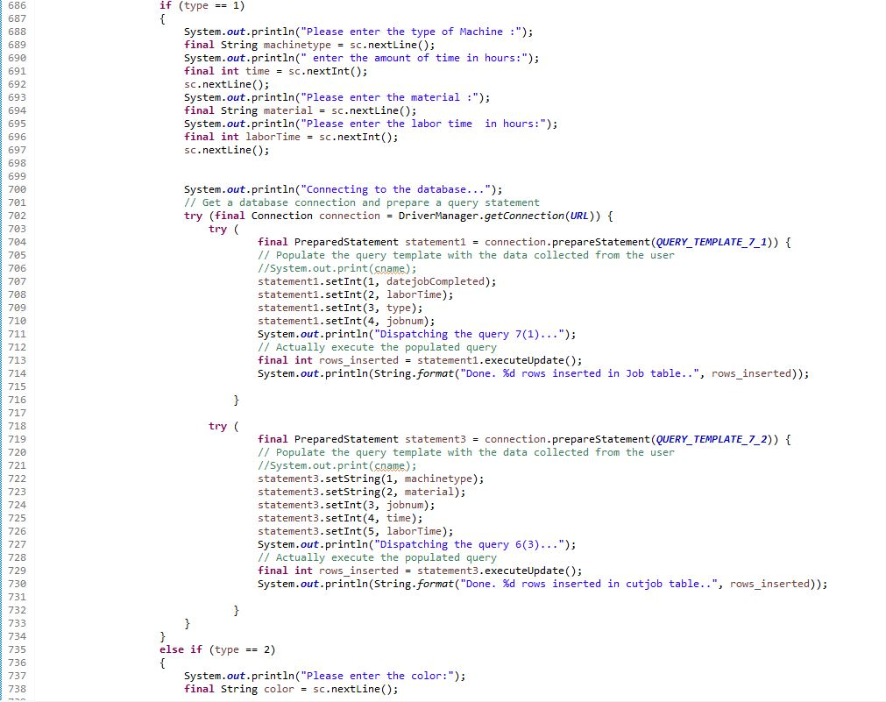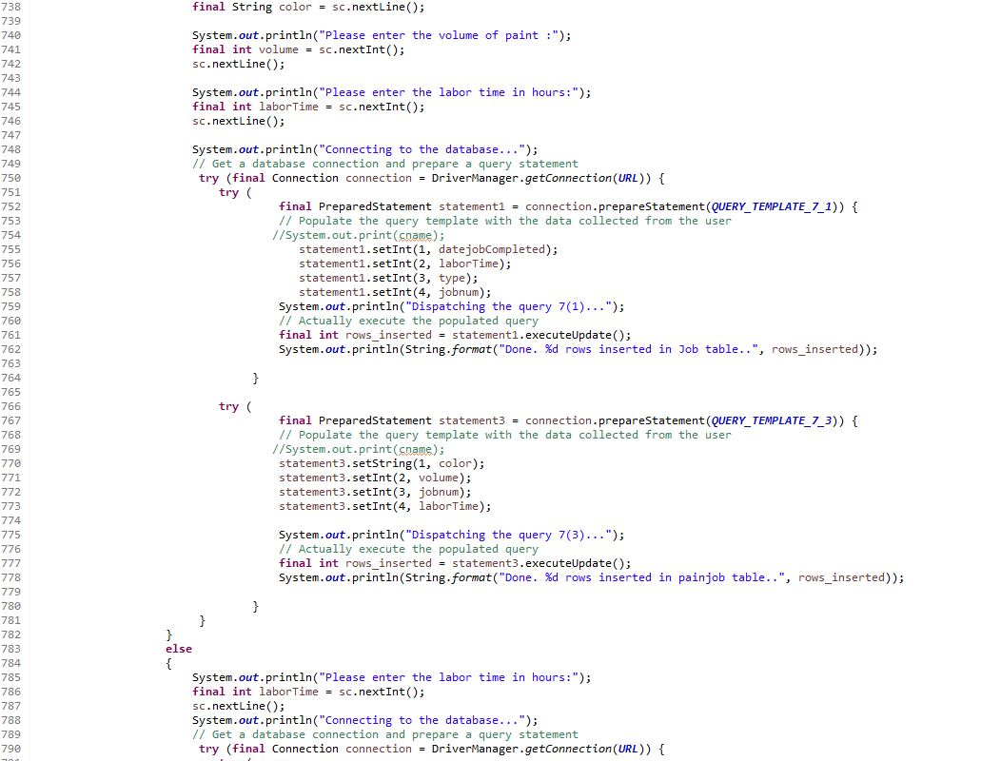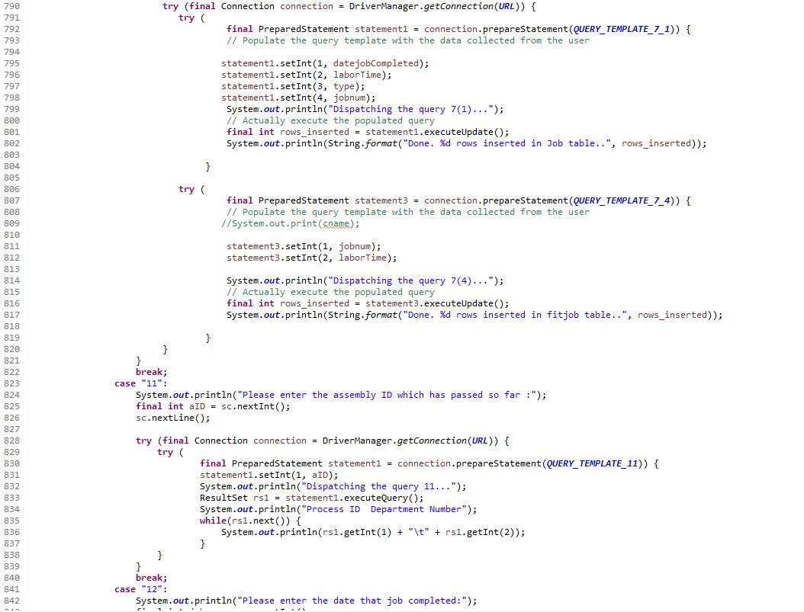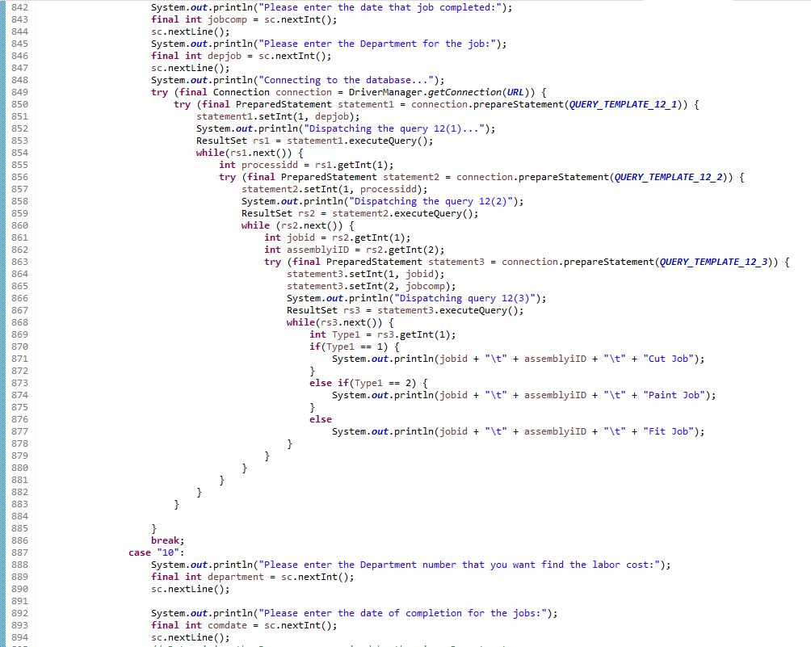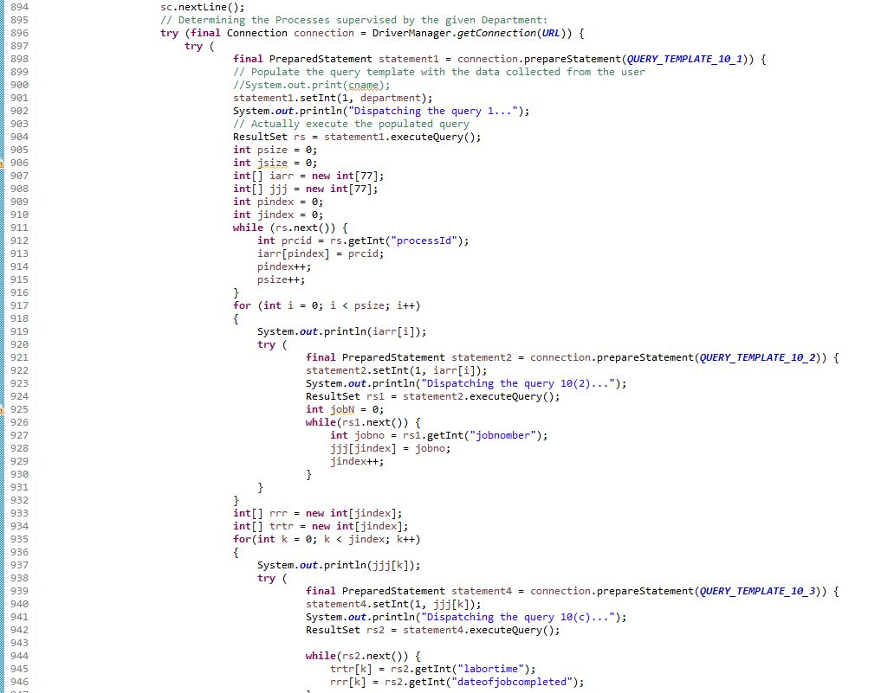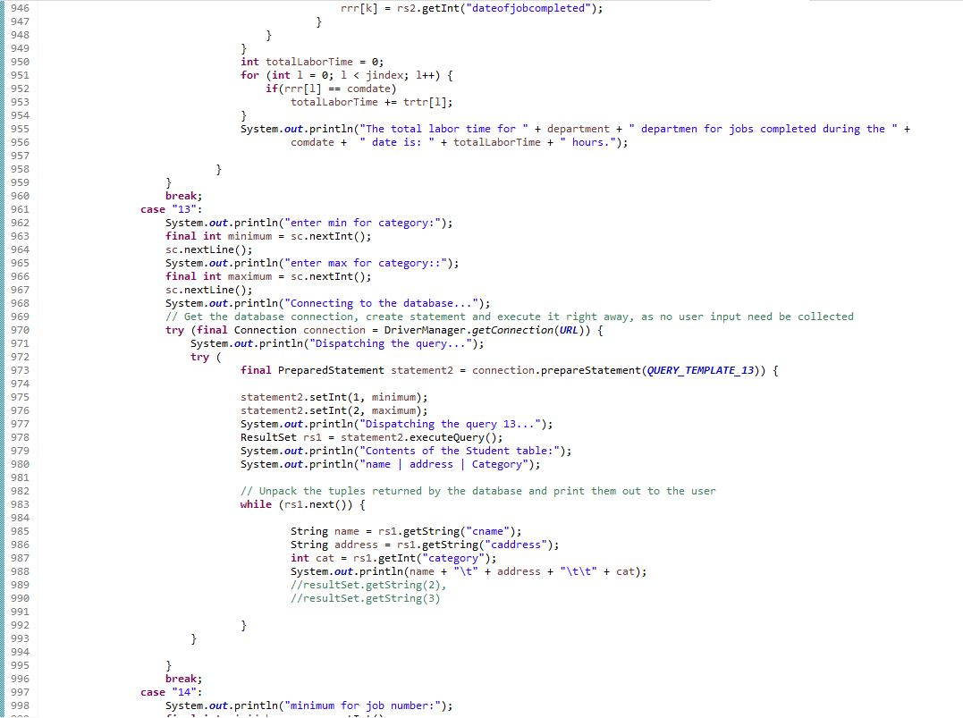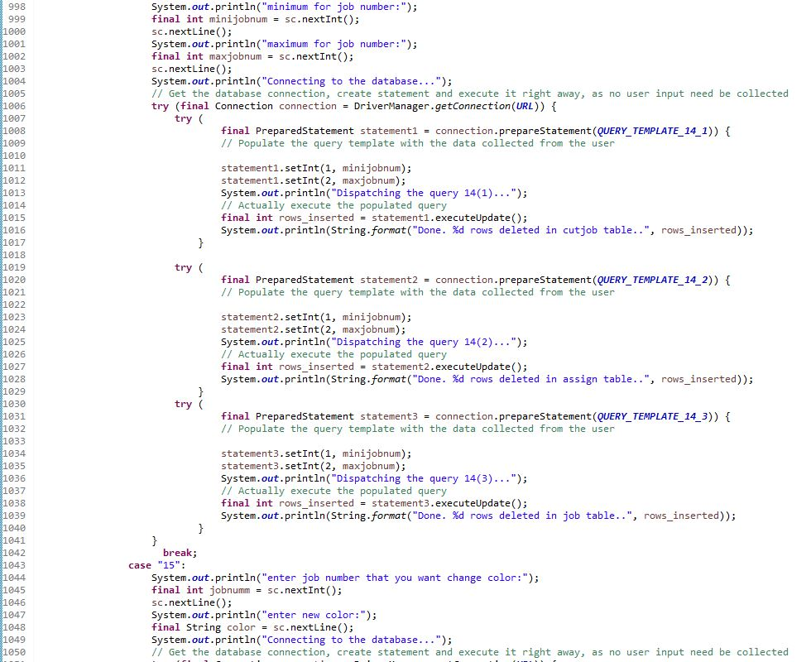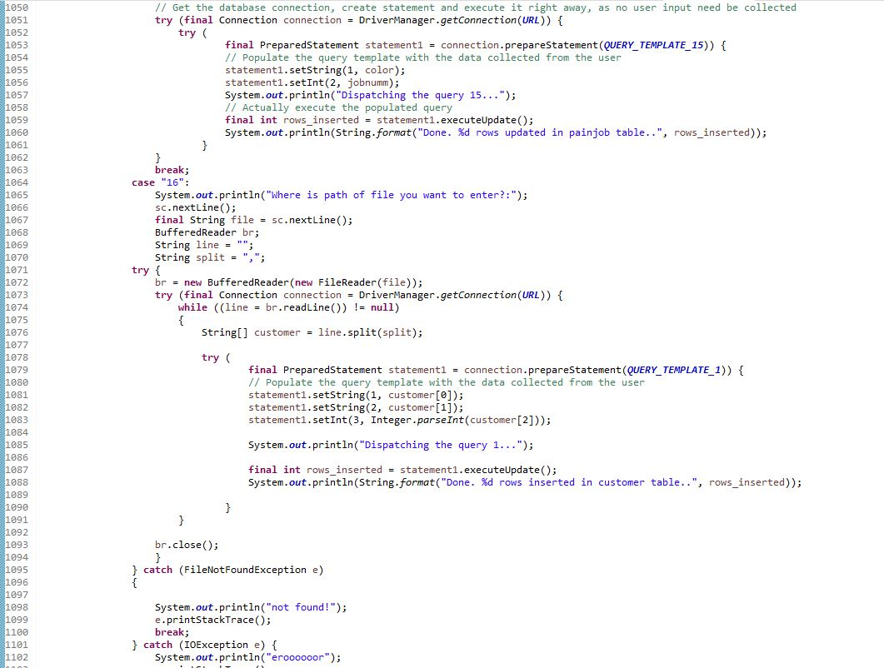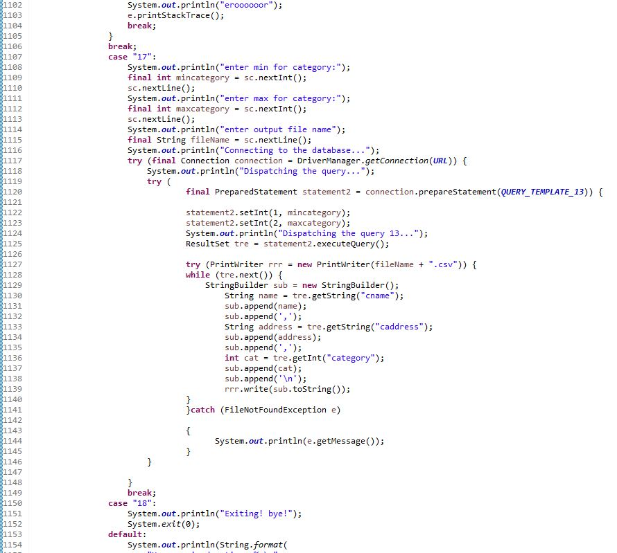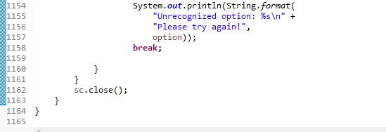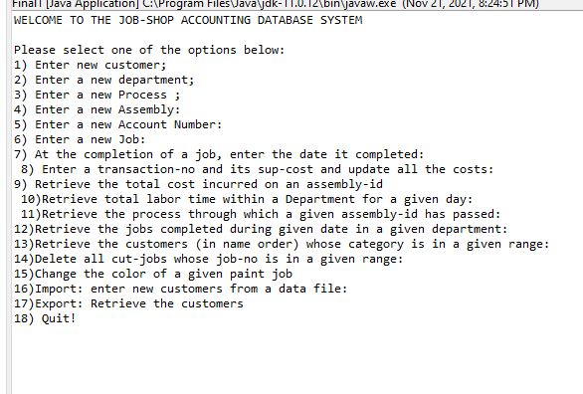

**Task 6**. Run the program created for Tasks 5 to test its correctness.

6.1.

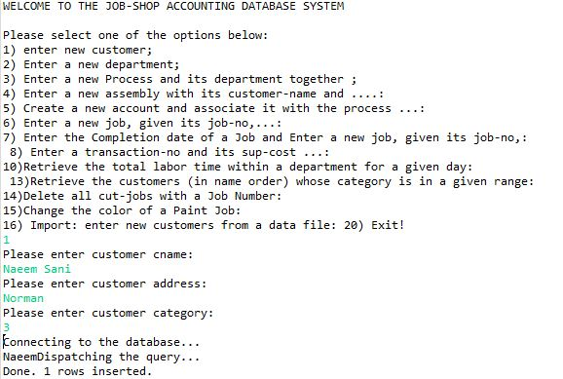

After 5 Run for query number 1.

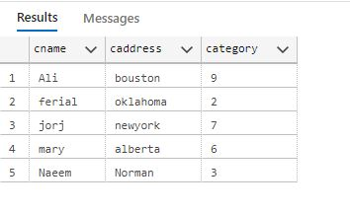

6.2

Query 2:

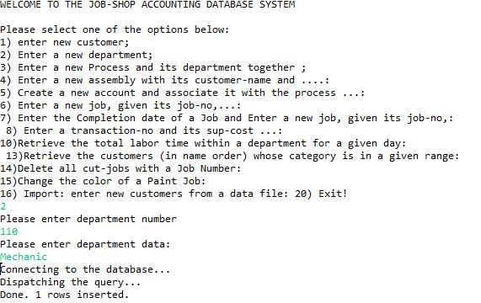

After 5 run for query 2

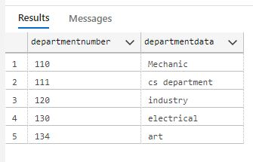

6.3

10 query for type 3.

Process table :

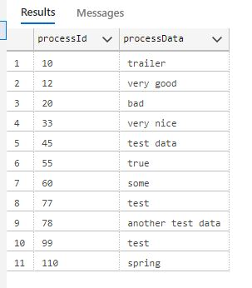

Cut table:

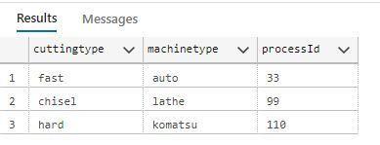

Paint table:

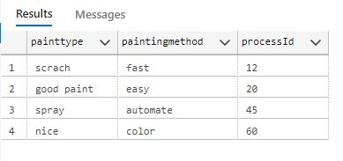

Fit table:

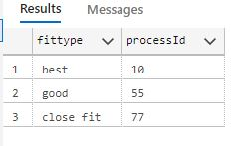

Supervise table:

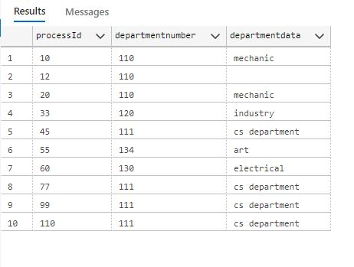

6.4.

10 query for type 4.

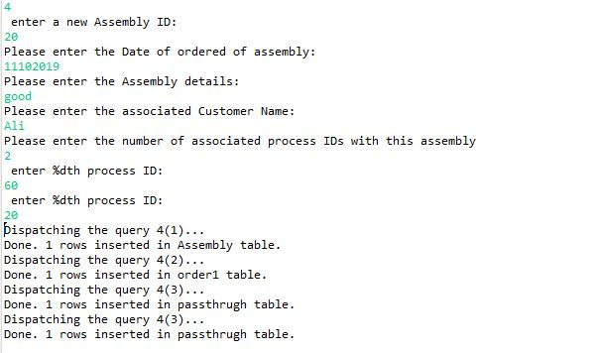

Assembly Table

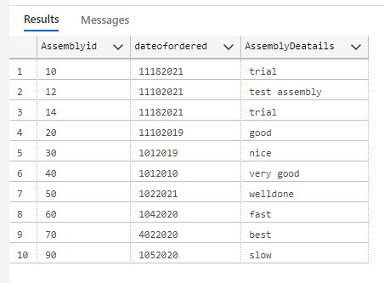

Order1 Table:

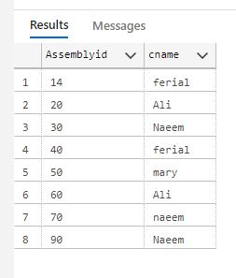

Pass-through Table:

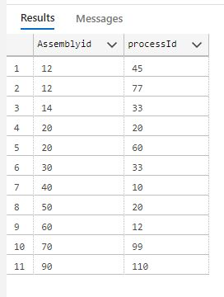

6.5.

10 query for type 5.

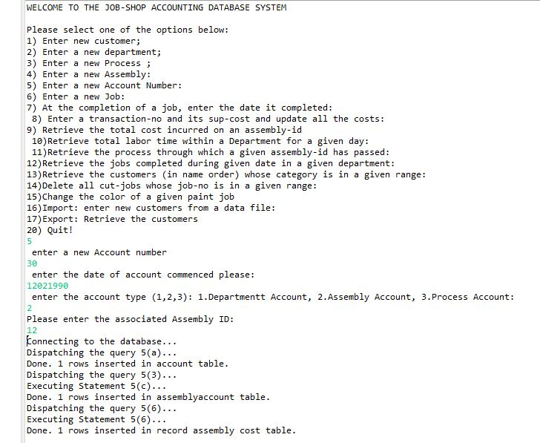

Account Table:

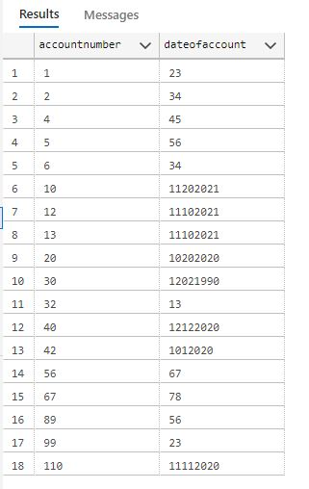

Process account table:

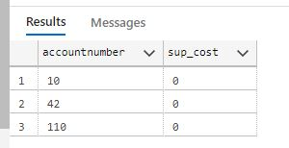

Department account table:

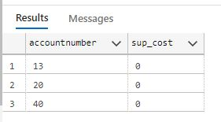

Assembly account table:

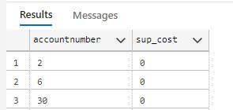

6.6.

10 query for type 6.

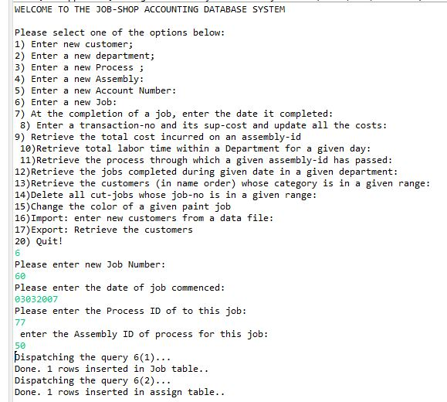

Job Table

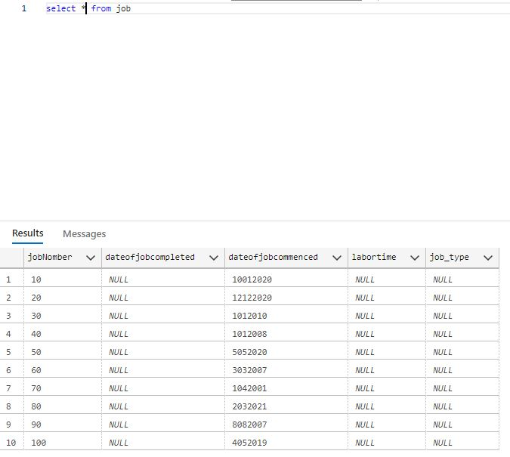

Assign Table:

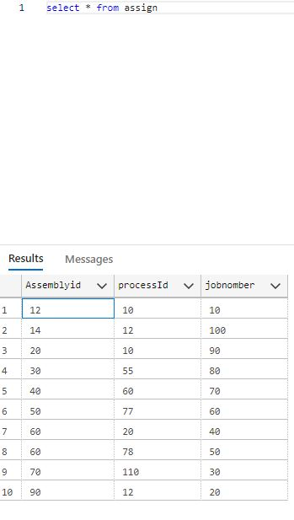

6.7.

10 query for type 7.

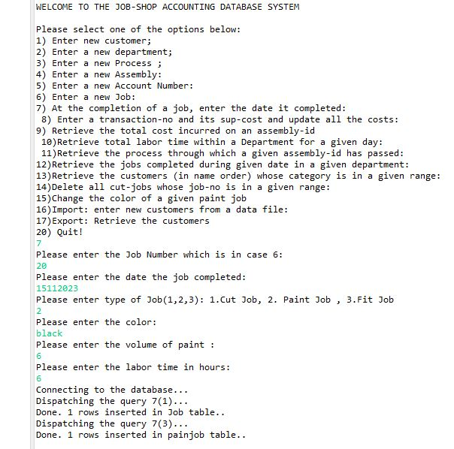

Job table:

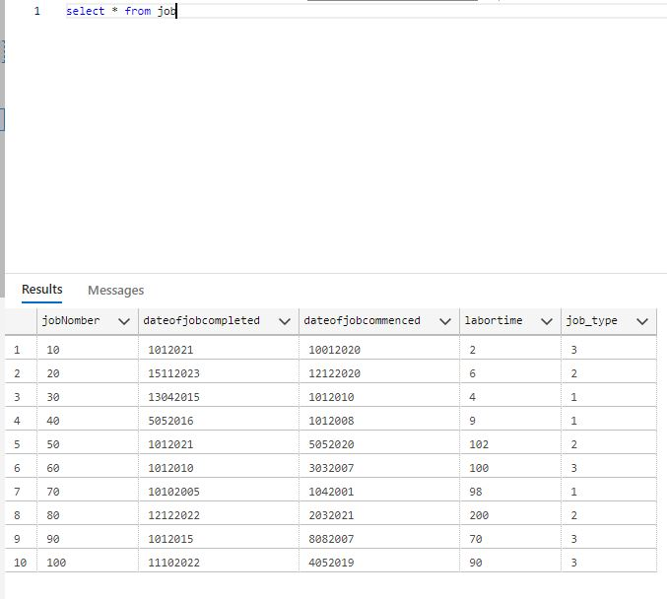

Cut job Table:

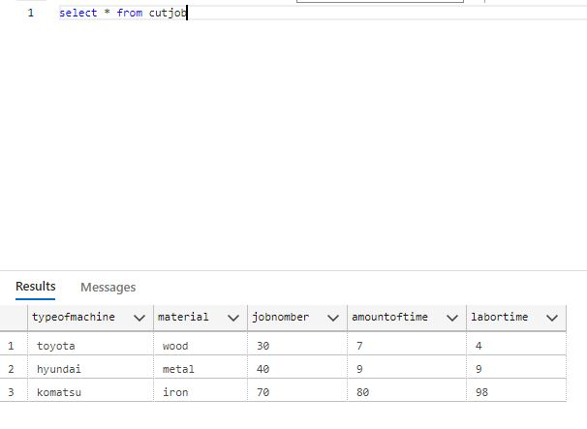

Paintjob Table:

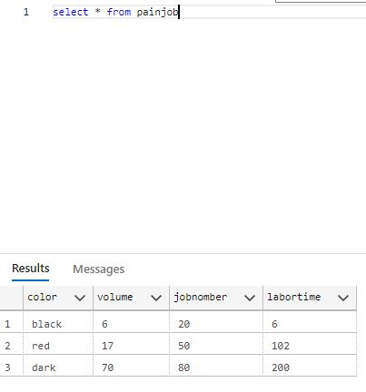

Fit job table:

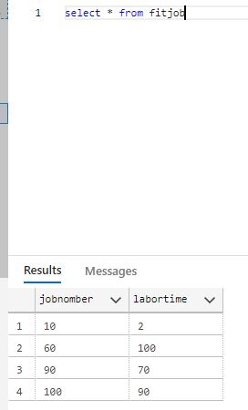

6.8

6.9.

6.10

3 query for type 10:

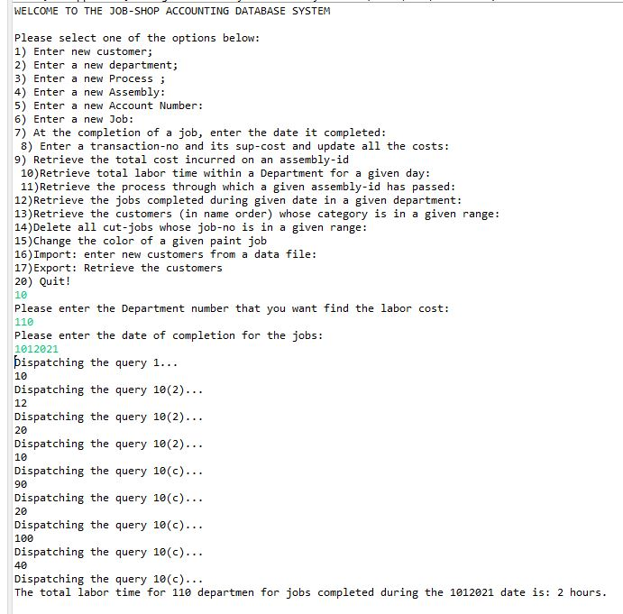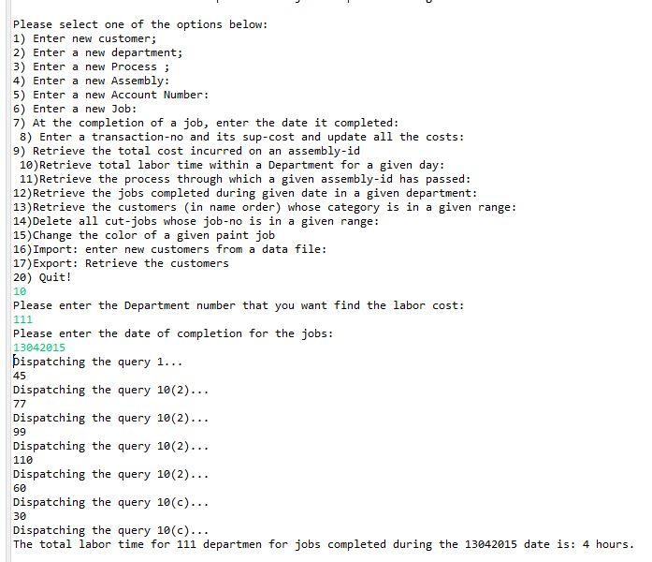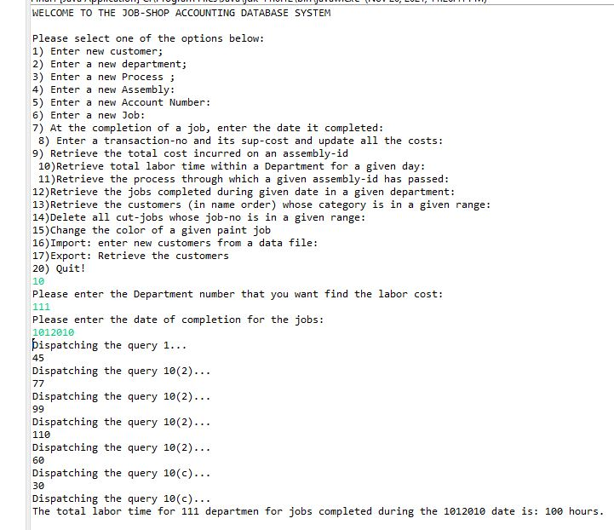

6.11.

3 query for type 11:

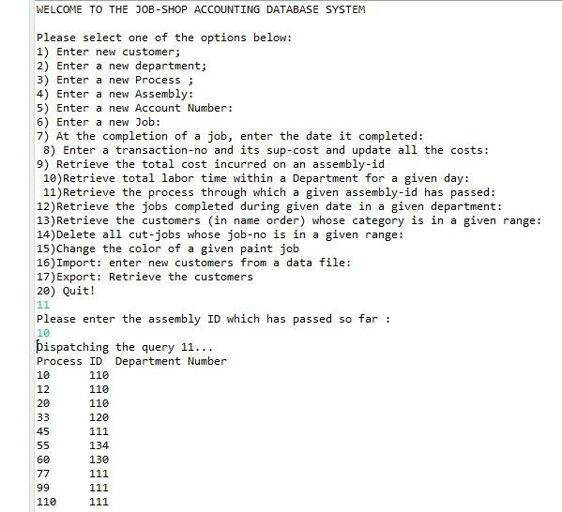

6.12.

3 query for type 12:

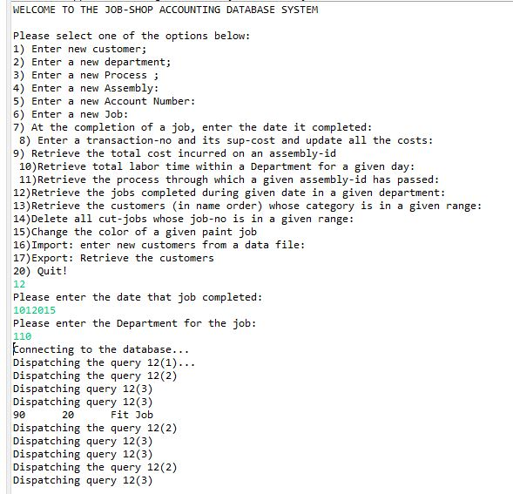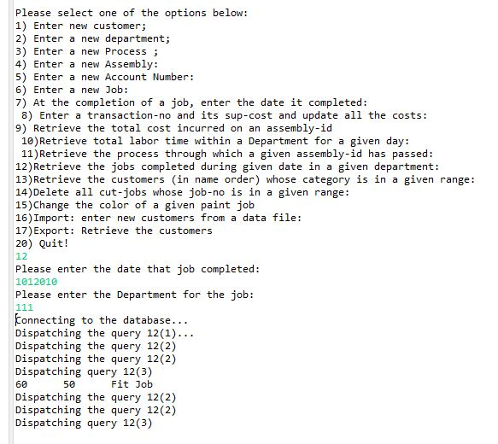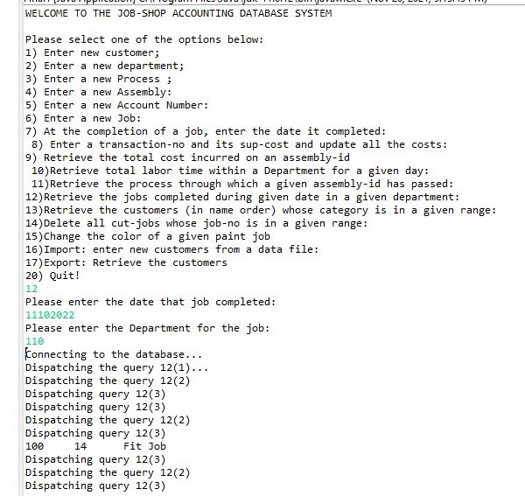

6.13.

3 query for type 13:

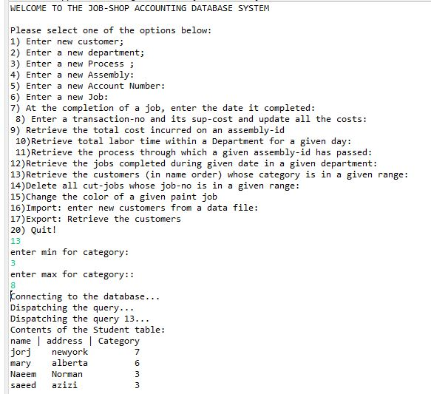

Run 2:

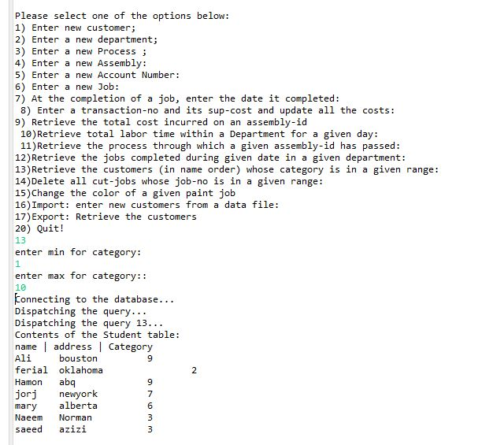

Run 3:

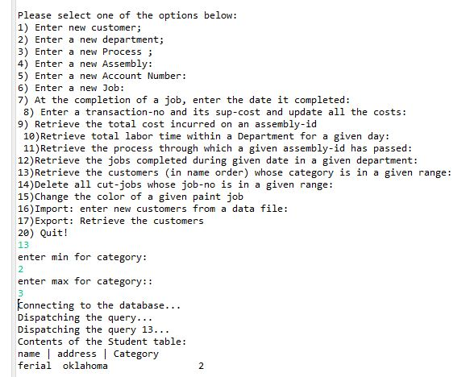

6.14.

3 query for 14:

This is a cut job table before run:

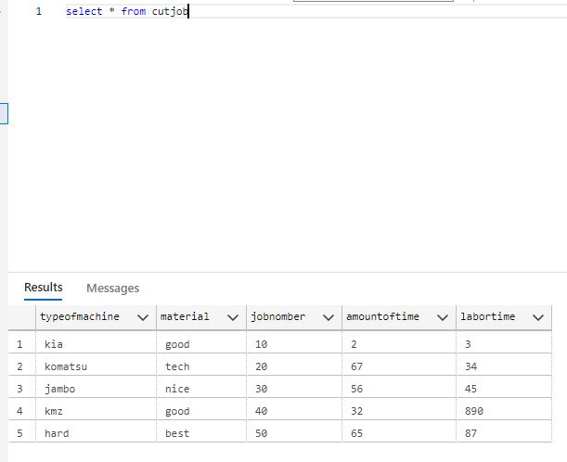

Run 1:

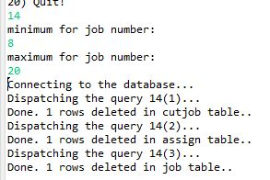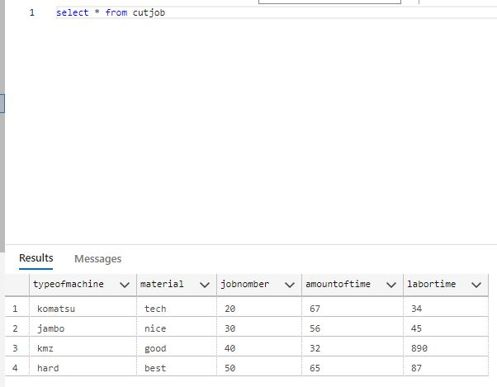

Run 2:

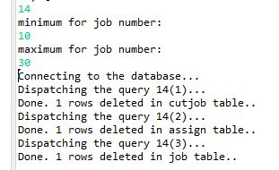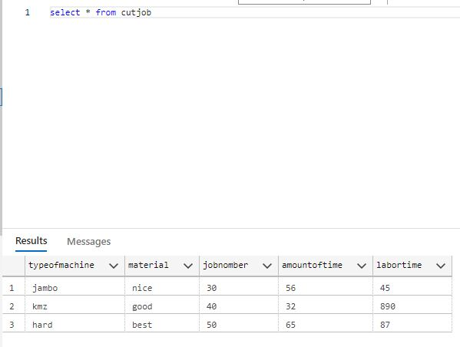

Run 3:

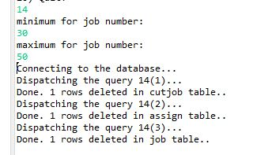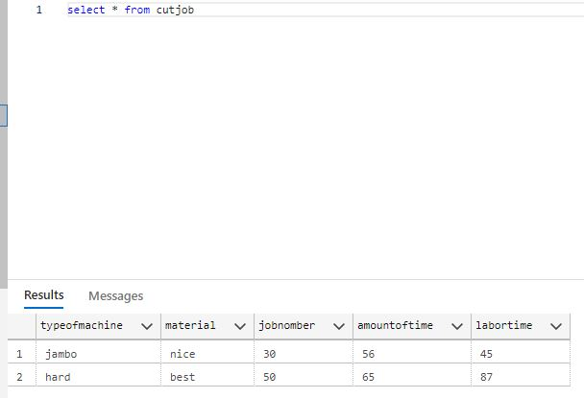

6.15.

3 query for 15:

This is paintjob table before run.

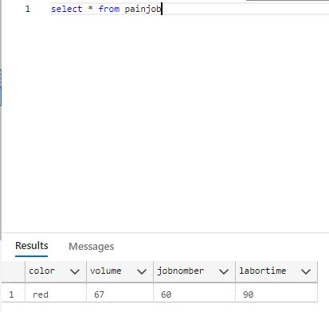

Run 1:

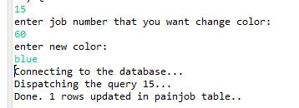

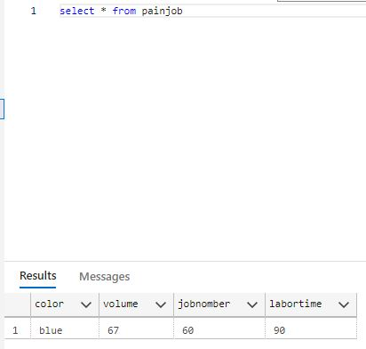

Run 2:

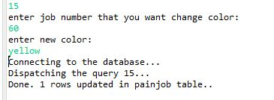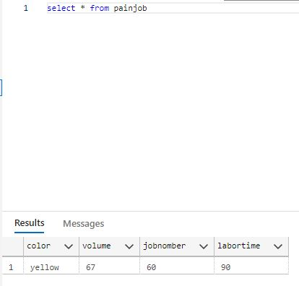

Run 3:

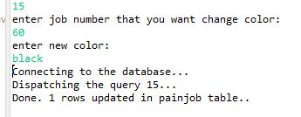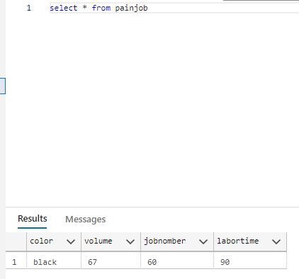

6.16.

1 run for query 16:

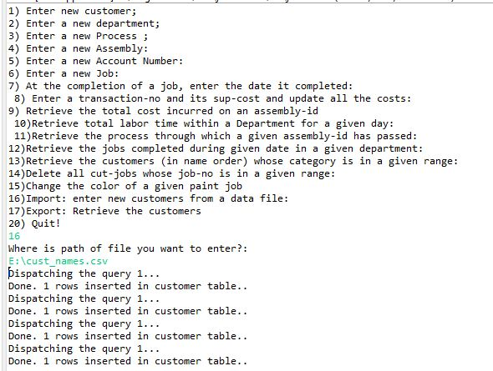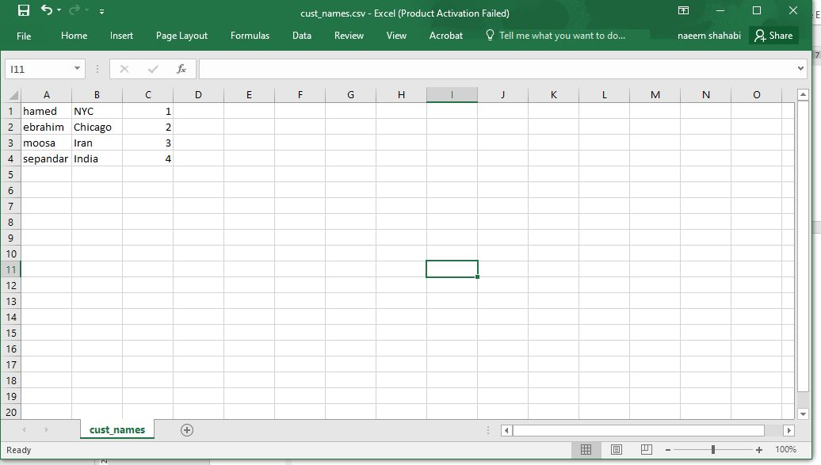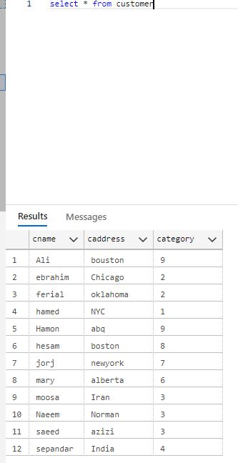

6.16.

1 run for query 17:

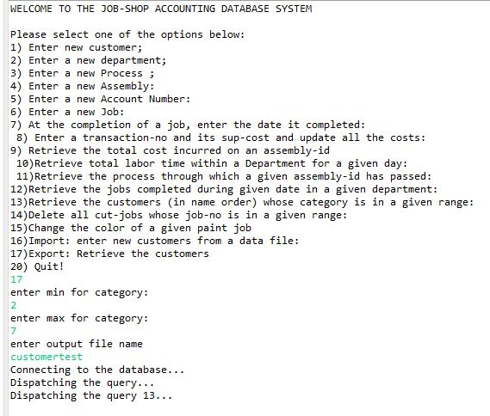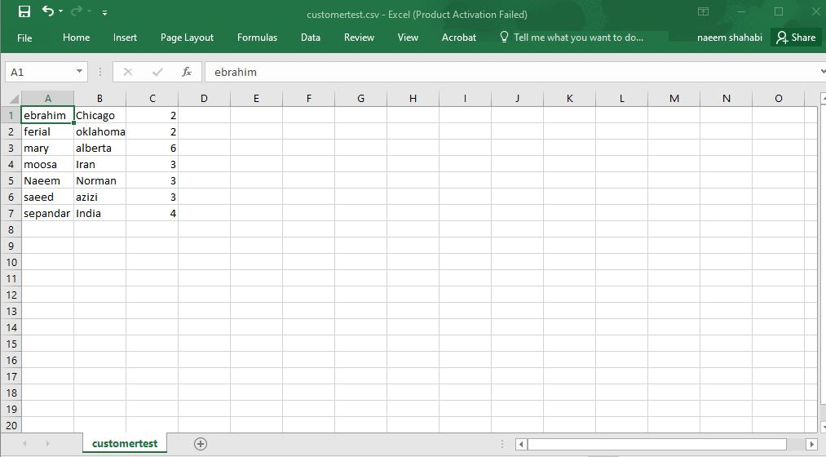

6.17.

Error checking.

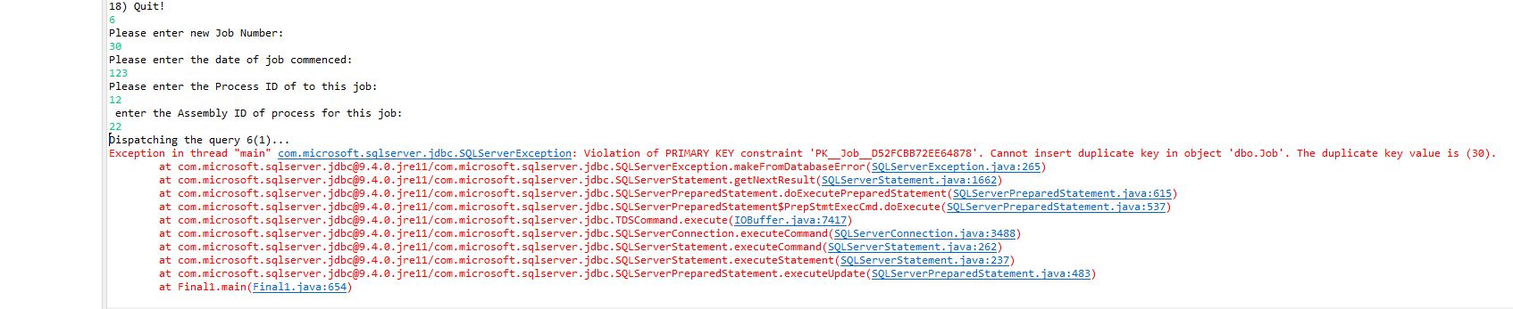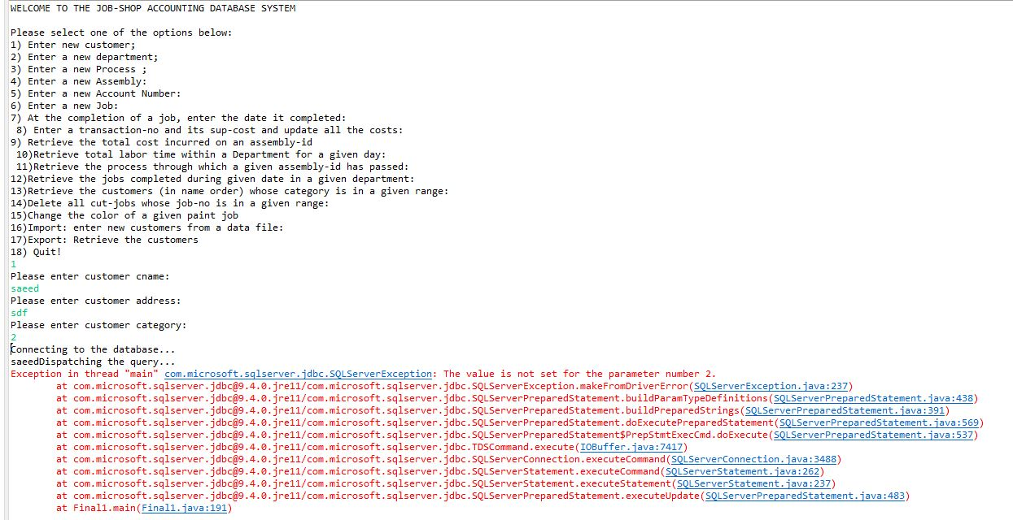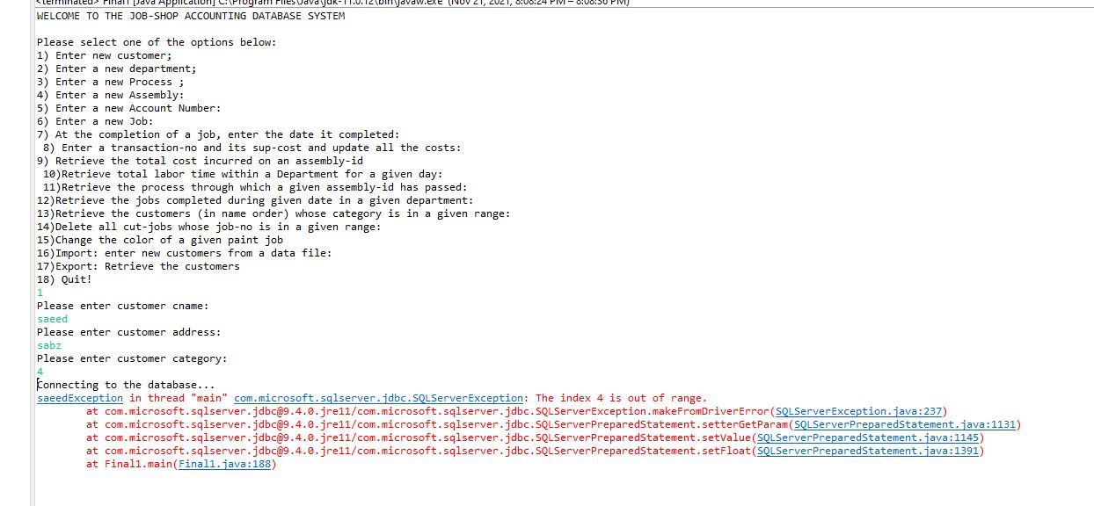

6.18.

Run query 18:

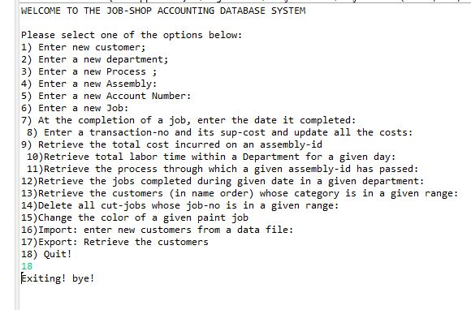

Question 7:

**7.1. Web database application source program and screenshots**

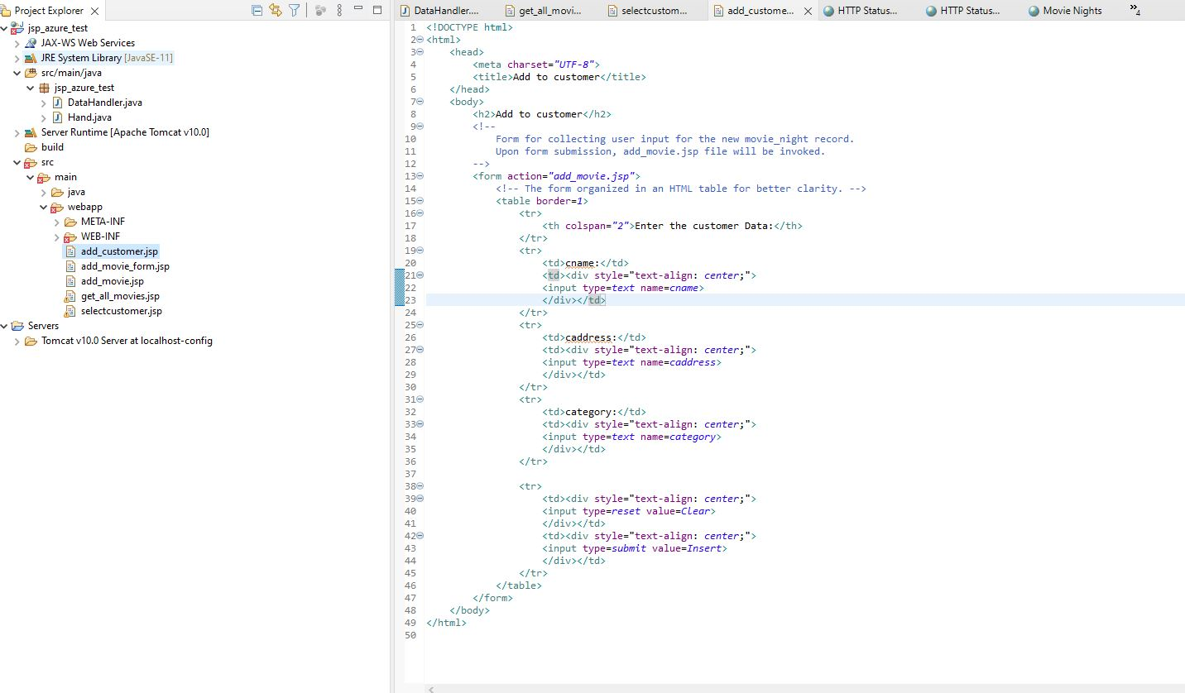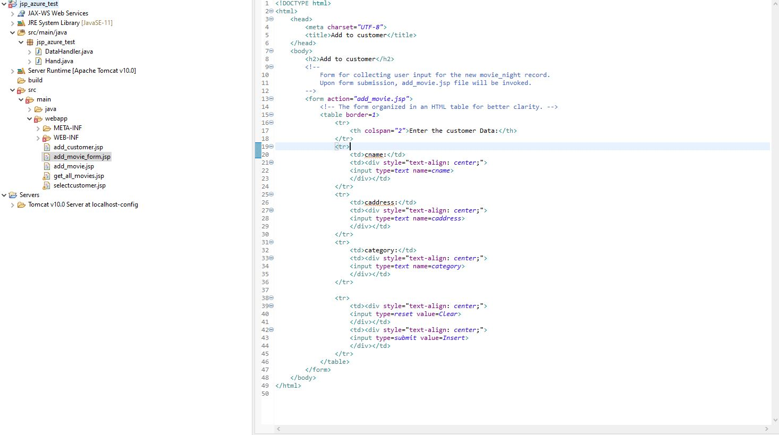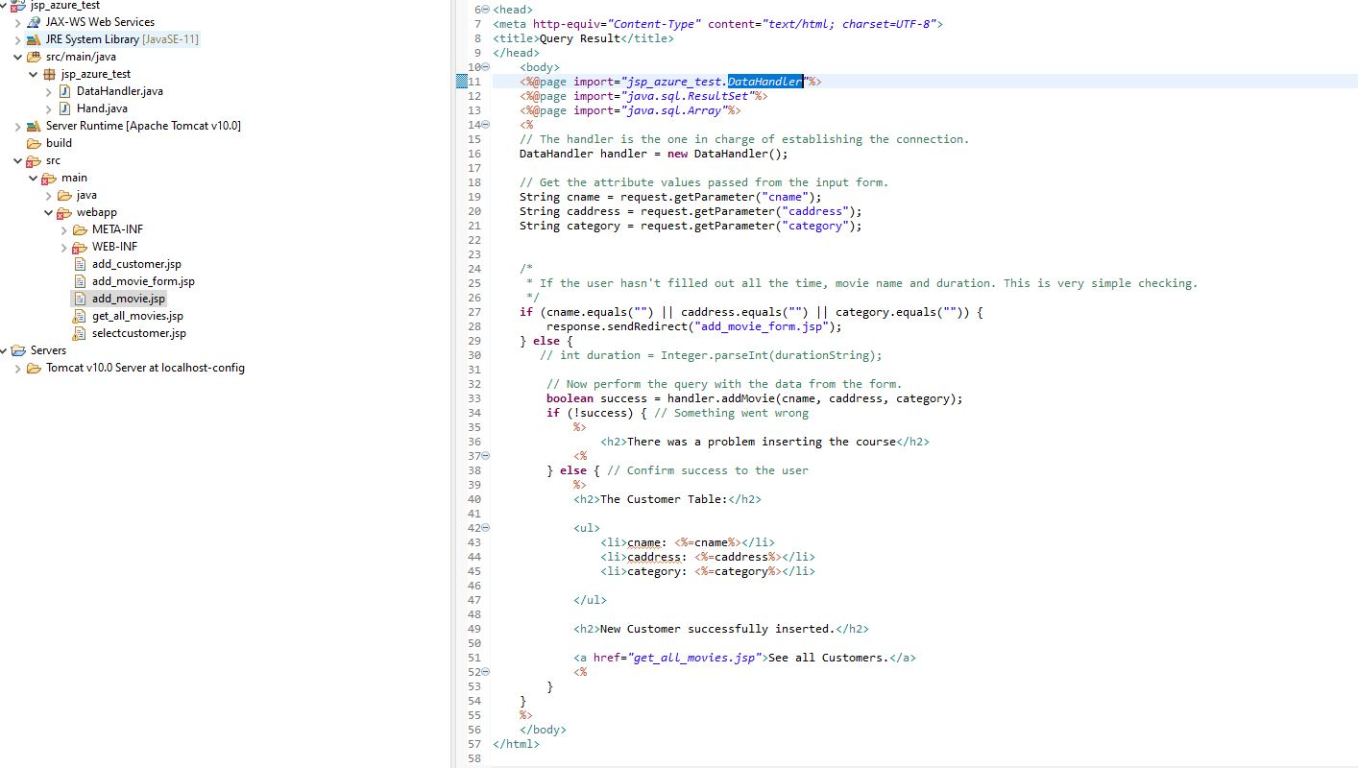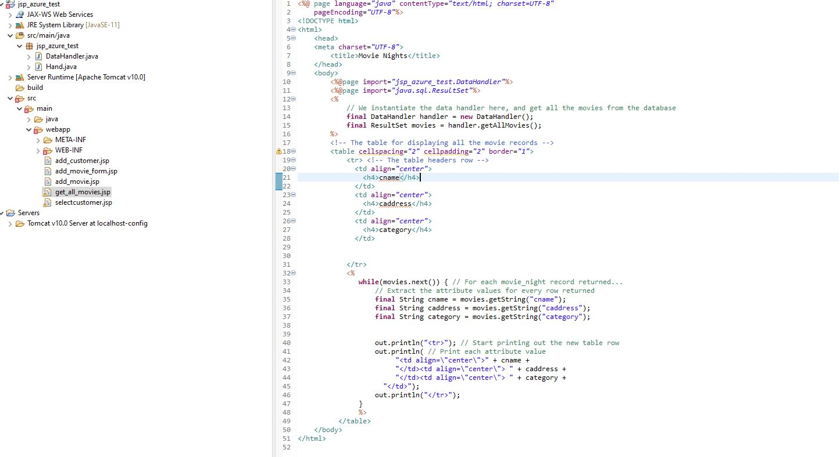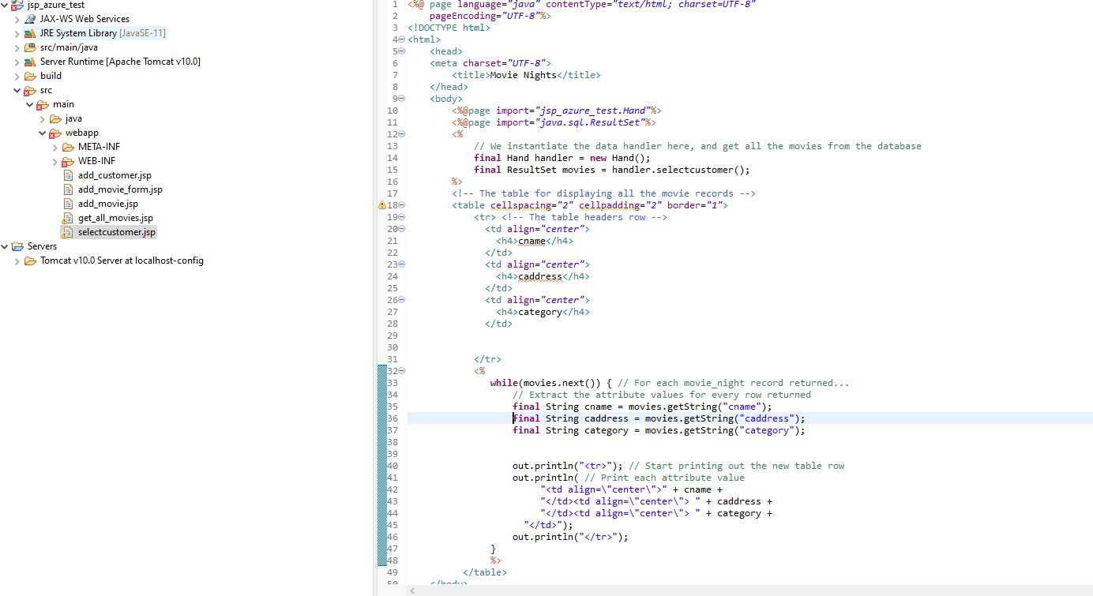

**7.2 Screenshots showing the testing of the Web database application**

Get_all_movies.jsp: Show all the customers in customer table.

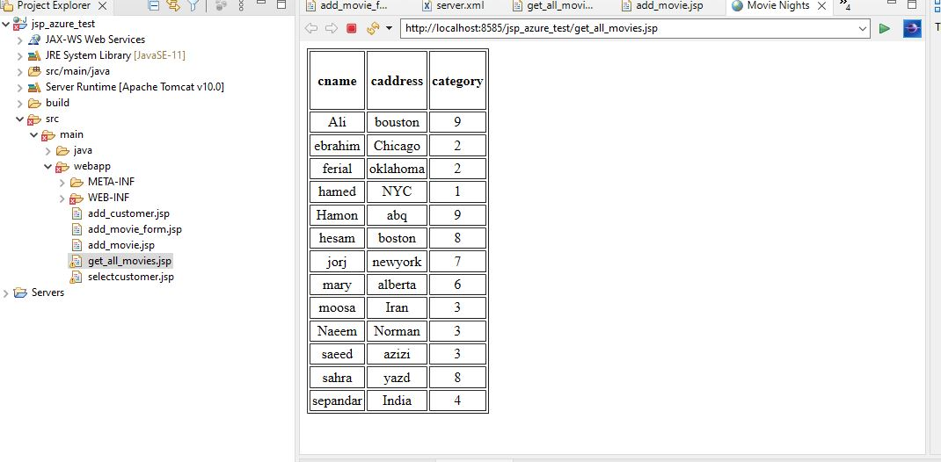

When run add_customer.jsp you can add a new customer.

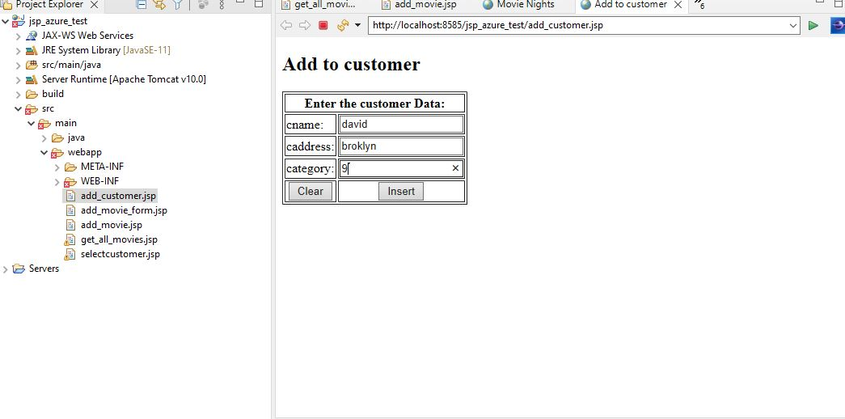

New customer added.

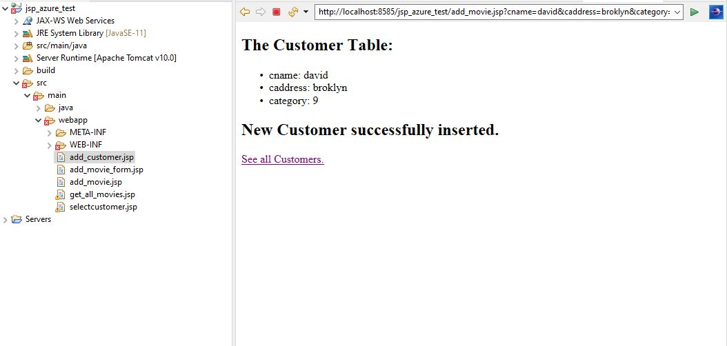

When you click on see all customers you can see customer table (david added).

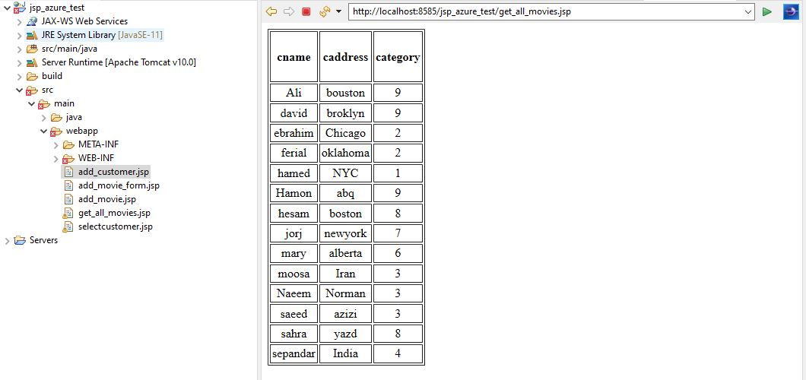

Selectcustomer.jsp show the customer in selected period.(here between 3 and 7)

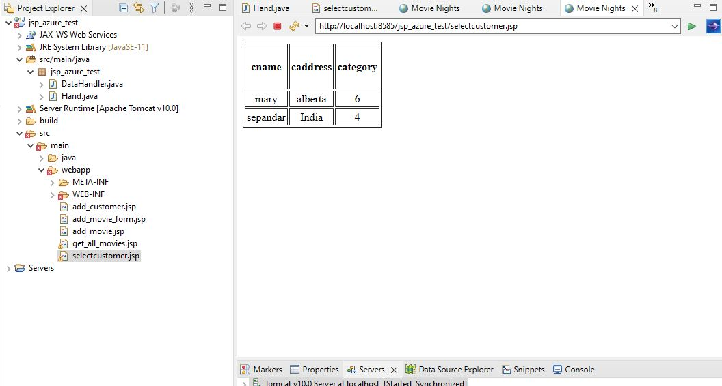

And here between 5 and 10.

